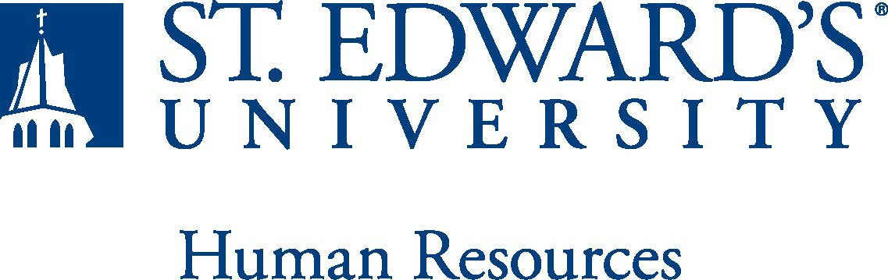

Job Title: Head Cheerleading Coach / Director of Spirit Operations, Fan Promotions and Engagement | FLSA Classification:  Exempt
Reports to: Associate Vice President for Athletics | Location: RAC
Department: Athletics | Division: Student Affairs
Employment Category: Full Time | Paygrade: 415
PRIMARY PURPOSE OF POSITION

The Head Cheerleading Coach / Director of Spirit Operations, Fan Promotions and Engagement will assist in meeting the university’s stated goals by providing strategic leadership and direction for the Cheerleading Team/Athletic Spirit Program and Fan Engagement.
ESSENTIAL DUTIES AND RESPONSIBILITIES

Head Sideline and Competitive Cheer Coach / Spirit Operations

Primary
- Direct and administer all aspects of the Spirit Program (cheer and mascot) within the rules, guidelines and principles of the university and Lone Star Conference.
  - Planning practices, coaching student-athletes through proper skill progressions, training and conditioning of student-athletes for sideline cheer, community events and competition
    - Conceive and script original cheers, chants and routines for games
  - Coordinate and oversee annual tryouts, in addition to conducting year-round recruiting to include attending local competitions
  - Oversee player development
    - Monitor academic progress and ensure that members are making progress toward graduation
    - Monitor player well-being
  - Manage operating budget
- Create and execute recruiting/retention program to attract and retain a diverse and talented pool of prospective student-athletes.
- Ensure that spirit program meets annual squad size requirement
- Collaborate with campus colleagues to proactively increase school spirit.

Secondary
- Arrange all phases of travel/lodging for all out-of-town events to be attended by spirit squads (i.e. public appearances, team camps, and competitions)
- Ensure that spirit fundraising goals are being met
- Plan, organize and execute youth camps and clinics to generate additional revenue to support the spirit program.
- Purchase and organize equipment
- Schedule, supervise and monitor community outreach program and public appearances by cheer team and mascot (K-12 schools, retirement homes, community events, etc0 ensuring that the team maintains and projects a positive image for the University
- Perform other administrative duties as assigned by Director of Athletics.

Director of Fan Promotions and Engagement

Primary
- Strategize, develop and implement innovative promotional and game atmosphere plans to increase attendance and fan experience elements that drive excitement, entertainment and informs the fans from pre-game through post game (i.e. tailgating, student-section activities, etc)
- Implement in-game marketing and fan engagement efforts to include in-game music, entertainment, scripts, video board fan engagement, and more
- Lead the strategy, planning and execution of fan and sponsorship game activations to ensure authentic, highly engaging, and varied content and an unparalleled fan experience
- Manage assigned social media channels, which includes planning, creating and executing daily content
- Collaborate closely with internal colleagues for highly engaging fan (and prospective fan) experiences
- Create fan development and community outreach initiatives
Secondary
- Conceptualize content and strategy for video board use
- Serve as liaison for athletic groups, key program influencers and other campus areas and provide genuine collaboration to bring initiatives to life
- Support other department initiatives and special projects as assigned

QUALIFICATIONS
- Baccalaureate degree with Master’s Degree preferred.
- Previous Sideline and competitive cheer coaching experience, preferably at the collegiate level, including player evaluation and recruiting
- American Association of Cheerleading Coaches and Administrators (AACCA) safety certification
- Ability to relate effectively with student-athletes
- Ability to motivate student-athletes to be successful students, athletes, and citizens
- Excellent interpersonal, oral and written communication, administrative, and organizational skills.
- Highly motivated with a capacity for independent work within the context of an intensely goal-oriented environment.
- Successful completion of an employment and/or criminal background check is required.
WORKING CONDITIONS
The individual holding this position must be able to work nights, weekends and holidays to meet the needs of the department.
PHYSICAL REQUIREMENTS

- Physically able to demonstrate skills.
- Physically able to “spot” during practices.
- Physically able to lift various materials up to 25 pounds on an occasional basis.
- While performing required job tasks, physically able to bend, crouch and reach continuously.
- While performing required job tasks, physically able to remain seated, frequently to continuously.
- While performing required job tasks, physically able to remain standing up to or more than 50% of the time.
- Possesses dexterity abilities required to operate a computer and other office equipment to perform related job responsibilities.
SUPERVISORY RESPONSIBILITIES
As a head coach, and director of promotions and fan engagement you will be required to supervise student workers.
EXPECTATIONS

- Strong organizational and time-management skills.
- Highly effective verbal and written communications skills.
- Excellent interpersonal skills, including collaboration, relationship building, and ability to respond positively and flexibly when working with all levels in the organization and with outside parties.
- Agility to work with student-athletes and coaches and should be comfortable speaking to groups of various sizes.
- Knowledge of NCAA DII and Lone Star Conference rules and regulations.
- Understanding of St. Edward’s University’s mission and goals is essential.
- Ability to work weekends and evenings, as well as occasional holidays, is required. This position requires non-traditional hours.
- Ability to exercise and apply sound judgment and decision-making skills as well as the ability to maintain integrity and confidentiality of data.
- Advanced knowledge of Microsoft Office and Google Suite software programs.
- Ability to quickly learn new technology and be self-motivated to stay current with emerging technologies.
- Ability to edit work for spelling and grammar, present numerical data effectively and read and interpret written information. Demonstrates accuracy and thoroughness and monitors own work to ensure quality.
- Ability to adapt to change in the work environment, manage competing demands and deal with frequent change, delays or unexpected events.
- Ability to accept supervision, assignments, change and correction. Proven effectiveness in dealing with a wide range of professionals, staff, and administrators.
- Ability to balance priorities to accomplish assigned tasks within the required time frame and be able to shift quickly between several tasks without loss of continuity.
- Ability and desire to be a strong team player and develop team dynamics within the athletic staff
- Desire to engage in meaningful and intentional professional development appropriate for areas of responsibility and actively engage in personal and campus well-being initiatives.
- Ability to carry out all responsibilities and objectives in a professional manner.
- Ability to develop knowledge of, respect for, and skills to engage with those of other cultures or backgrounds in accordance with the Holy Cross Mission.
- Ability to adhere to the policies and procedures established by St. Edwards University.

This document describes the general purpose, duties and essential functions associated with this job and is not an exhaustive list of all duties that may be assigned or skills that may be required. I have read and understand my job description and acknowledge that management reserves the right to change or reassign job duties or combine jobs at any time.

Employee (Print Name): Date:

Employee (Signature): Date:

 | HR OFFICE USE ONLY:
Approved by: |  | Signature of the person with the authority to approve the job  description
Printed Name of  Approver: |  | Printed name of the person with the authority to approve the job  description.
Date  approved: |  | Date upon which the job description was approved
Reviewed: |  | Date when the job description was last reviewed

