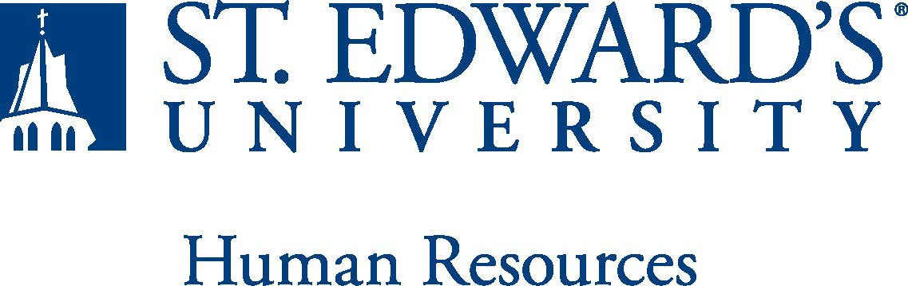

Job Title: Assistant Athletic Trainer / Instructor, Department of Kinesiology | FLSA Classification:  Exempt
Reports to: Assistant Athletic Director for Sports Medicine | Location: RAC
Department: Athletics | Division:
Employment Category: Full Time | Paygrade: 413
PRIMARY PURPOSE OF POSITION

The assistant athletic trainer will assist the university in meeting the goals of the mission statement, athletic department and department of Kinesiology by providing:
- Approximately three contact hours of teaching either one Kinesiology lecture course or multiple practicums in Athletic Training and,
- A safe environment for university sponsored practices and competitions and,
- A comprehensive university athletic training program delivering quality care for student-athletes in the 10 NCAA DII sports.

The assistant athletic trainer will operate such that the overall quality and integrity of the department aligns with the university’s vision of excellence. This position reports directly to the Assistant Director of Athletics for Sports Medicine for responsibility in critical areas of prevention, evaluation, rehabilitation, referral and documentation of athletic injuries, as well as to the Department of Kinesiology Chair for responsibility in providing a comprehensive overview of objectives, skills, concepts, materials, and methods necessary for kinesiology students to perform in a kinesiology-based setting.
ESSENTIAL DUTIES AND RESPONSIBILITIES

Primary
- Teaching a kinesiology course and/or practicum in the kinesiology department
- Coordinate the medical care of student-athletes of assigned sports
- Provide on-field/court athletic training services for assigned sport programs
- Implement appropriate injury prevention and rehabilitation programs
- Maintain accurate medical documentation of athletic injuries

Secondary
- Assist in supervision of the daily operation of the athletic training facility
- Assist in maintenance of the athletic training equipment, supplies, and facilities
- Travel, as necessary, with assigned sport programs
- Assist in recruitment, education, and daily supervision of athletic training students including documentation related to licensure
- Maintain continuing education hours as required for athletic training licensure/certification
- Be an engaged member of the athletic department and university community and other duties as assigned.

QUALIFICATIONS
- Masters’ Degree in athletic training, kinesiology or closely related field required.
- Knowledge of and/or experience working with kinesiology students.
- Previous teaching experience is preferred
- Texas Department of State Health Services License required, or eligible for licensure
- NATA BOC certification required
- NSCA CSCS preferred
- Two to five years athletic training experience, with two years of experience at the collegiate level preferred
- Excellent interpersonal, oral and written communication, and organizational skills
- A demonstrated commitment to high academic standards and healthy lifestyles for student-athletes
- Ability to work in the outdoor elements and on evenings, week-ends, and holidays
- Successful completion of an employment and/or criminal history background check required.
WORKING CONDITIONS
The individual holding this position must be able to work nights, weekends and holidays to meet the needs of the department. Practice and games take place indoors, as well as outdoors and weather conditions will vary.
PHYSICAL REQUIREMENTS
The expectations listed below are representative of the abilities that may be needed to fulfill the essential functions of this position. Reasonable accommodations may be made to enable individuals with disabilities to perform the essential functions. Physical strength/endurance to enable him/her to perform/participate in the following activities:

- Physically able to lift various materials up to 50 pounds on an occasional basis.
- While performing required job tasks, physically able to bend, crouch and reach continuously.
- While performing required job tasks, physically able to remain seated, frequently to continuously.
- While performing required job tasks, physically able to remain standing up to or more than 50% of the time.
- Possesses dexterity abilities required to operate a computer and other office equipment to perform related job responsibilities.
SUPERVISORY RESPONSIBILITIES
As a full-time assistant athletic trainer, you may sometimes be required to supervise the undergraduate athletic training students in execution of tasks.
EXPECTATIONS

- Strong organizational and time-management skills.
- Highly effective verbal and written communications skills.
- Excellent interpersonal skills, including collaboration, relationship building, and ability to respond positively and flexibly when working with all levels in the organization and with outside parties.
- Agility to work with student-athletes and coaches and should be comfortable speaking to groups of various sizes.
- Knowledge of NCAA DII and Lone Star Conference rules and regulations.
- Understanding of St. Edward’s University’s mission and goals is essential.
- Ability to work weekends and evenings is required. This position requires non-traditional hours.
- Ability to exercise and apply sound judgment and decision-making skills as well as the ability to maintain integrity and confidentiality of data.
- Advanced knowledge of Microsoft Office and Google Suite software programs.
- Ability to quickly learn new technology and be self-motivated to stay current with emerging technologies.
- Ability to edit work for spelling and grammar, present numerical data effectively and read and interpret written information. Demonstrates accuracy and thoroughness and monitors own work to ensure quality.
- Ability to adapt to change in the work environment, manage competing demands and deal with frequent change, delays or unexpected events.
- Ability to accept supervision, assignments, change and correction. Proven effectiveness in dealing with a wide range of professionals, staff, and administrators.
- Ability to balance priorities to accomplish assigned tasks within the required time frame and be able to shift quickly between several tasks without loss of continuity.
- Ability and desire to be a strong team player and develop team dynamics within the athletic staff
- Desire to engage in meaningful and intentional professional development appropriate for areas of responsibility and actively engage in personal and campus well-being initiatives.
- Ability to carry out all responsibilities and objectives in a professional manner.
- Ability to develop knowledge of, respect for, and skills to engage with those of other cultures or backgrounds in accordance with the Holy Cross Mission.
- Ability to adhere to the policies and procedures established by St. Edwards University.

This document describes the general purpose, duties and essential functions associated with this job and is not an exhaustive list of all duties that may be assigned or skills that may be required. I have read and understand my job description and acknowledge that management reserves the right to change or reassign job duties or combine jobs at any time.

Employee (Print Name): Date:

Employee (Signature): Date:

 | HR OFFICE USE ONLY:
Approved by: |  | Signature of the person with the authority to approve the job  description
Printed Name of  Approver: |  | Printed name of the person with the authority to approve the job  description.
Date  approved: |  | Date upon which the job description was approved
Reviewed: |  | Date when the job description was last reviewed

