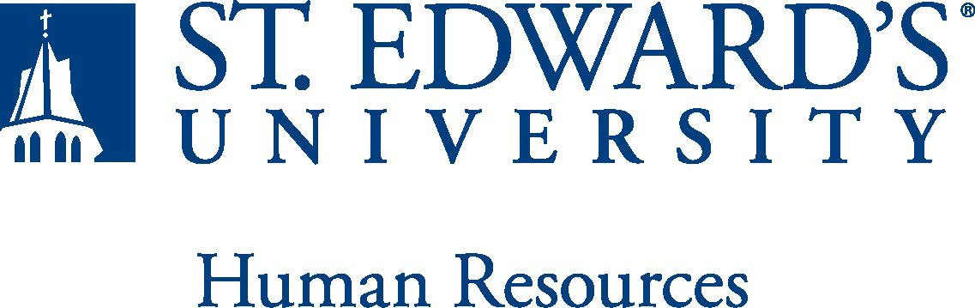

Job Title: Director, International Student Services PDSO/RO | FLSA Classification:  - Exempt  - Nonexempt
Reports to:  International Student Services | Location:
Department: | Division:
Employment Category:  - Full-Time ☐ Part-Time | Paygrade:
PRIMARY PURPOSE OF POSITION

The director serves as the PDSO/RO (Primary Designated School Official/Responsible Officer) and manages the broad spectrum of service areas related to student visa holders. The position supervises immigration and visa-related service functions in compliance with federal regulations and reporting requirements. This role provides essential services that serve the students’ educational, professional, and social goals and understands the challenges and strengths that are unique to this population. This position provides leadership toward the planning and implementation of successful initiatives for the student visa holder as well as maintaining strategic plans that enable a comprehensive support for this population. This position reports to the Associate Vice President for Student Success.
ESSENTIAL DUTIES AND RESPONSIBILITIES
- Serve as Primary Designated School Official (PDSO) and Responsible Office (RO) for a small population of student visa holders
  - Ensure DSO/ARO staff are fully trained on immigration regulations and updated on policies, procedures, and regulations.
  - Acts as school liaison to state and federal agencies; such as DHS, Department of State, USCIS, SSA, etc.
  - Serve as the university designated contact and program administrator for Ellucian International Student & School Management system. (ISSM)
- Oversee immigration compliance with regulations for F & J visas.
  - Review policies/procedures; writes Annual Report; updates program information in SEVIS.
  - Train and update DSO/ARO staff on immigration regulations, policies, and procedures.
  - Oversee the health insurance requirements and waiver process for international students and exchange visitors.
  - Research, interpret, and apply federal and institutional rules and policies to the specific situations of international students in F-1 or J-1 non-immigrant status.
  - Manage SEVIS and ISSM database and updates to International Student Services webpages.
- Advise F & J international students on immigration matters
  - Counsel students on immigration from recruitment to post graduation
  - Support and advise students on career and internship compliance (OPT/CPT)
  - Review, analyze and stay abreast of federal regulations and procedures affecting international students
  - Research, recommend, communicate, and implement appropriate practices and procedures that support students with maintaining their immigration and academic status
  - Provide direct, comprehensive advising to international students in regards to complex issues not only related to immigration but also related to academic, travel, and career development issues.
  - Provide oversight for the Foundations Course for International Students.

- Serve as liaison to faculty and staff in regard to the intersection of immigration regulation and academic success.
  - Serve as a liaison between international students, faculty, and all campus partners (i.e. Student Involvement, Career Services, Success Coaches, Health and Counseling Center, Financial Services, etc.) to integrate international educational services to the overall university function
  - Contribute to the development, implementation, and presentation of specialized workshops/ programs/information seminars as well as informational text oversight, such the website, handouts/forms, office processes and workflow
  - Committed to retention initiatives and demonstrates this through active involvement in educational guidance for student, faculty, and staff
  - Actively participate in developing university guidelines for implementation of immigration regulations for student visa holders

QUALIFICATIONS
- U.S. citizenship or Lawful Permanent Resident status required per federal regulations for certification as a Designated School Official
- Bachelor’s degree required; master’s preferred
- 5 -10 years working with Student visa holders at the PDSO/RO level or with advanced DSO/ARO training and experience. Strong background in interpreting regulations for student visa holders.
- Flexible schedule, weekend work and/or additional hours required.
- Familiarity with federal/state agencies that work with international students and visitors
- Strong problem-solving, decision-making, and conflict resolution skills
- Experience with Ellucian International Student & School Management or similar software systems.
- Works independently, as well as, in teams and is highly motivated
- Can process large volumes of detailed-oriented paperwork in support of international student status
- Ability to maintain a professional demeanor and composure, amidst challenging interpersonal interactions
- Ability to effectively manage multiple projects in a fast-paced work environment.
- Ability to communicate effectively in a multilingual/multicultural environment, interpersonally, orally and in writing, with supervisors, co-workers, faculty, students, and campus partners.
- Successful completion of an employment and/or criminal history background check required.

WORKING CONDITIONS
SCHEDULE: This is an exempt position and your expected work schedule is Monday through Friday. As an exempt employee your schedule may vary based on the number of hours needed to meet the job responsibilities. The individual holding this position may need to be available early morning, evening, and weekends to meet the needs of the department.
PHYSICAL REQUIREMENTS

To perform this job successfully, an individual must be physically able to perform each essential duty satisfactorily. The expectations listed below are representative of the skills and/or abilities required. Reasonable accommodations may be made to enable individuals with disabilities to perform the essential functions:
- Physically able to lift various materials up to 25 pounds on an occasional basis.
- While performing required job tasks, physically able to bend, crouch and reach continuously.
- While performing required job tasks, physically able to remain seated, frequently to continuously.
- While performing required job tasks, physically able to remain standing up to 15% of the time.
- Possesses dexterity abilities required to operate a computer and other office equipment to perform related job responsibilities.
SUPERVISORY RESPONSIBILITIES

SUPERVISION RECEIVED: Direct supervision from the AVP.
EXPECTATIONS

SUPERVISION EXERCISED: None.

The incumbent is expected to have or possess:
- Ability to handle highly confidential material, understanding that all university information should only be disclosed to others who have a need to know, for legitimate business reasons. Have the ability to exercise and apply sound judgment and decision making skills as well as the ability to maintain integrity and confidentiality of data.
- Has advanced knowledge of Microsoft Office and Google Suite software programs. Ability to quickly learn new technology and is self-motivated to stay current with emerging technologies.
- Adapt to change in the work environment, manage competing demands and able to deal with frequent change, delays or unexpected events.
- Ability to comply with workplace guidelines and attendance requirements.
- Ability to accept supervision, assignments, change and correction. Proven effectiveness in dealing with a wide range of professionals, staff, and administrators.
- Ability to balance priorities to accomplish assigned tasks within the required time frame and be able to shift quickly between several tasks without loss of continuity.
- Carry out all responsibilities and objectives in a professional manner.
- Accept and render constructive criticism in a professional manner.
- The ability to develop knowledge of, respect for, and skills to engage with those of other cultures or backgrounds in accordance with the Holy Cross Mission.
- Adhere to the policies and procedures established by St. Edwards University.

This document describes the general purpose, duties and essential functions associated with this job and is not an exhaustive list of all duties that may be assigned or skills that may be required.
I have read and understand my job description and acknowledge that management reserves the right to change or reassign job duties or combine jobs at any time.

Employee (Print Name): Date:

Employee (Signature): Date:

 | HR OFFICE USE ONLY:
Approved by: |  | Signature of the person with the authority to approve the job  description
Printed Name of  Approver: |  | Printed name of the person with the authority to approve the job  description.
Date  approved: |  | Date upon which the job description was approved
Reviewed: |  | Date when the job description was last reviewed

