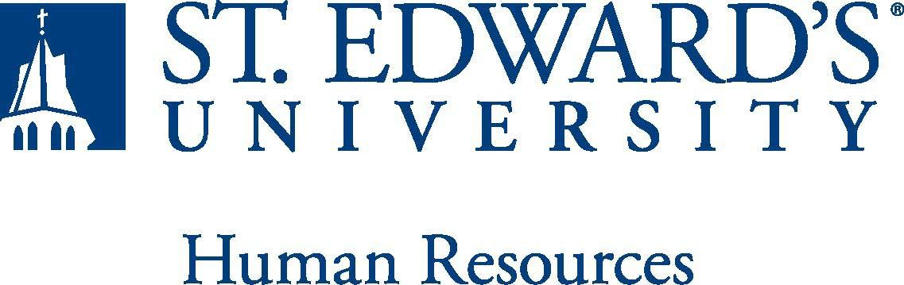

Job Title: Student Engagement and Communications Coordinator | FLSA Classification:  - Exempt ☐Nonexempt
Reports to: Associate Vice President for Student Success | Location:
Department: Student Affairs | Division: Student Success Center
Employment Category:  - Full-Time ☐ Part-Time | Paygrade: 416
PRIMARY PURPOSE OF POSITION

Responsible for developing, writing, and distributing print, digital and social media content that follows content strategy best practices, communicates key Student Success Center brand and strategic plan messages, and fulfills the Center’s communications and marketing strategic goals. In addition, this position provides leadership in developing and implementing small to large scale programming and events in support of students and alumni. This includes coordination of event setup and logistics, while closely collaborating with Student Success Center personnel to develop and execute outreach and communication strategies for internal (students, faculty, staff) and external (employers and graduate/professional school recruiters) stakeholders. The position reports to the Associate Vice President for Student Success.

ESSENTIAL DUTIES AND RESPONSIBILITIES

Communications
- Manage day-to-day activities, including writing and creating a wide variety of content, promotions, email communications, and newsletters to promote student retention efforts.
- Cultivate and promote the Student Success Center brand in coordination with the university’s Marketing Office and institutional guidelines
- Create marketing/communication plans and editorial calendars for areas and strategic initiative within the Student Success Center.
- Create reports for Student Success Center offices using marketing analytics and engagement measurements to drive student participation.
- Create and maintain content for the division’s web pages and social media accounts.
- Serve as primary administrator for the Student Success Center Instagram account.
- Manage the Student Success Center’s use of email marketing software through Emma.
- Supervise the Student Success Center’s student graphic design staff and interns.
- Responsible for event promotion for each area within the Student Success Center, in coordination with area liaisons and student staff and interns.
- In coordination with the division and university partners, generate, edit, publish and share content that builds meaningful connections and encourages community members to take action using available tools.
- Lead efforts to build online engagement, capture and engage new audiences, coordinate campaigns and targeted online outreach programs to promote brand awareness and drive key audiences to the Student Success Center outlets and collaterals.
- Research and recommend new opportunities to enhance the areas social media presence.
- Continuously improve by capturing and analyzing the appropriate social data/metrics, insights and best practices, and then acting on the information.
- Assist with managing the innovative digital for the division.

Student Engagement and Programming
- Provide leadership in developing and implementing strategies for creating/enhancing programming and events for the Student Success Center.
- Serve as primary contact and coordinator of all employer/recruitment activities, including development, marketing and implementation in collaboration with the Career staff.
- Orchestrate and lead all campus employer events in collaboration with the Career staff, including, but not limited to fall and spring career fairs, part-time job fairs, graduate/professional school fairs, and recruitment tabling events.
- Develop and execute outreach and marketing strategy and collateral designed to attract campus recruiting partners.
- Develop and execute outreach and marketing strategy and collateral designed to drive event attendance at Student Success Center events.
- Collect, analyze, and interpret data on events/programming and student learning outcomes.
- Become knowledgeable of the university’s various programs and majors to identify and develop programming and recruitment events reflective of the diversity of St. Edward’s academic offerings
- Other duties as assigned.
QUALIFICATIONS

- Bachelor’s degree or equivalent work-related experience required
- A minimum of 2 years of experience in managing digital and social media communication including: planning, content development, analysis and reporting
- Minimum of one year experience in professional event management; recruiting, employer relations or career coaching/advising in a university or industry setting preferred
- In depth knowledge of social media platforms, web design and Adobe Creative Suite
- Excellent consulting, writing, editing (photo/video/text), presentation and communication skills required
- Knowledge of digital marketing and good understanding of major marketing channels
- Working knowledge of Google Analytics
- Strong organizational skills
- Ability to work independently and as part of a team, exhibiting strategic thinking, sound judgment, initiative, and flexibility
- Ability to work with a broad range of internal and external constituents including students, employers, alumni, faculty, and staff
- Must possess the ability to successfully pass a criminal background check
Typical office environment
WORKING CONDITIONS

PHYSICAL REQUIREMENTS
- Physically able to lift various materials up to 25 pounds on an occasional basis.
- While performing required job tasks, physically able to bend, crouch and reach continuously.
- While performing required job tasks, physically able to remain seated, frequently to continuously.
- While performing required job tasks, physically able to remain standing up to 15% of the time.
- Possesses dexterity abilities required to operate a computer and other office equipment to perform related job responsibilities.
- Physically able to spend significant time reading both on paper and on a computer.
- Ability to travel by car and plane for University business.
- Ability to drive.

SUPERVISORY RESPONSIBILITIES
Student Workers

EXPECTATIONS
The incumbent is expected to have or possess:
- Ability to handle highly confidential material, understanding that all University information should only be disclosed to others who have a need to know, for legitimate business reasons.
- Have the ability to exercise and apply sound judgment and decision making skills as well as the ability to maintain integrity and confidentiality of data.
- Ability to quickly learn new technology and is self-motivated to stay current with emerging technologies.
- Ability to edit work for spelling and grammar, present numerical data effectively and is able to read and interpret written information.
- Demonstrates accuracy and thoroughness and monitors own work to ensure quality. ·
- Ability to manage day-to-day activities, including writing and maintaining content including emails, web pages, event promotion, newsletters, print materials and community-outreach efforts.
- Adapt to change in the work environment, manage competing demands and able to deal with frequent change, delays or unexpected events.
- Ability to accept supervision, assignments, change and correction. Proven effectiveness in dealing with a wide range of professionals, staff, and administrators.
- Ability to balance priorities to accomplish assigned tasks within the required time frame and be able to shift quickly between several tasks without loss of continuity.
- Engage in meaningful and intentional professional development appropriate for areas of responsibility and actively engage in personal and campus well-being initiatives.
- Carry out all responsibilities and objectives in a professional manner.
- Accept and render constructive criticism in a professional manner.
- The ability to develop knowledge of, respect for, and skills to engage with those of other cultures or backgrounds in accordance with the Holy Cross Mission.
- Adhere to the policies and procedures established by St. Edward's University.

This document describes the general purpose, duties and essential functions associated with this job and is not an exhaustive list of all duties that may be assigned or skills that may be required

