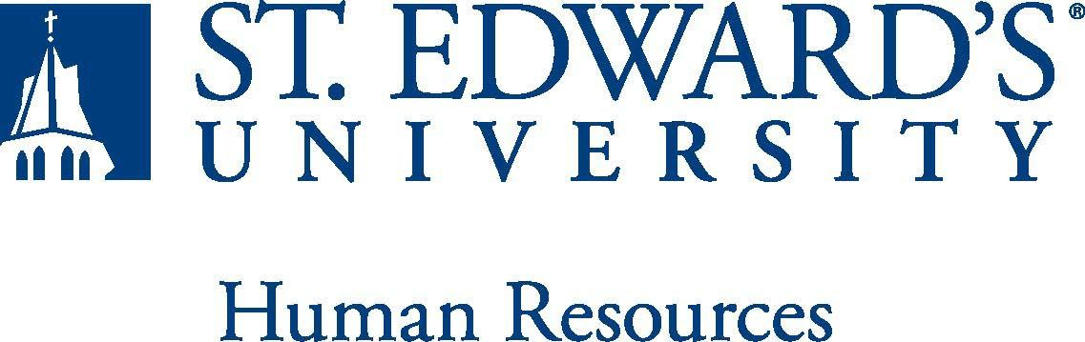

Job Title: Residence Director | FLSA Classification:  ☒Exempt ☐Non Exempt
Reports to: Director of Residential Education | Location: St. Edwards University - St. Andre Apts
Department: Residence Life | Division: Student Affairs
Employment Category:  ☒Full-Time ☐ Part-Time | Paygrade: 414
PRIMARY PURPOSE OF POSITION

Provide a brief description of the general nature of the position; an overview of why the job exists; and what the job is to accomplish. The job purpose is usually no more than four sentences long.

The Residence Director is a full-time staff member serving in a 12-month live-in position. The Residence Director’s primary responsibility is to ensure that residence halls are safe and functional for all students and that student staff are well trained. The Residence Director is responsible for the administrative, educational, and supervisory tasks of a residential community. Duties of the RD includes staff supervision, administrative duties, student conduct, stimulating the development of educational, social and personal growth programs.

ESSENTIAL DUTIES AND RESPONSIBILITIES

Essential Responsibilities Include:
- Hire, train, supervise and evaluate 4-12 Resident Assistants and 10-12 Office Assistants.
- Coordinate the administrative functions of a residential community, which include facility management, maintenance, room assignments, student employment, and payroll budget.
- Provide leadership in promoting an atmosphere within the residential communities that supports academic achievement and fosters responsible decision-making.
- Coordinate community and student development through service-learning initiatives, social and educational programming, human issues education, faculty involvement programming, and hall council advising.
- Oversee building office operations and customer service training of student employees.
- Provide advice and counsel for individual students, student leaders, and student groups.
- Participate in an on-call duty program in which student crises are addressed and a follow-up is conducted.
- Respond to requests and inquiries from university personnel, students, and parents.

QUALIFICATIONS
Master's degree in college student personnel education or closely related field experience. One year of professional experience in a university setting. Knowledge of higher education, learning and human development theory and student affairs. Demonstrated experience in the supervision of staff and management of a community living facility. Demonstrated commitment and ability to work with a diverse student body and staff Commitment to the concepts of community, social justice, pluralism, social equity, and the integration of mind, body, and spirit within the context of a liberal Catholic University. Must possess an unencumbered driver's license and the ability to successfully pass a criminal background check.

WORKING CONDITIONS
This position is considered essential staff and the staff may be required to work when the university is officially closed. The position also entails occasionally working in the evenings and on the weekends.
PHYSICAL REQUIREMENTS

- Physically able to lift various materials up to 25 pounds on an occasional basis.
- While performing required job tasks, physically able to bend, crouch and reach continuously.
- While performing required job tasks, physically able to remain seated, frequently to continuously.
- While performing required job tasks, physically able to remain standing up to 15% of the time.
- Possesses dexterity abilities required to operate a computer and other office equipment to perform related job responsibilities.

SUPERVISORY RESPONSIBILITIES
Supervises student employees: Resident Assistants and Office Assistants
EXPECTATIONS

N/A

This document describes the general purpose, duties and essential functions associated with this job and is not an exhaustive list of all duties that may be assigned or skills that may be required.

