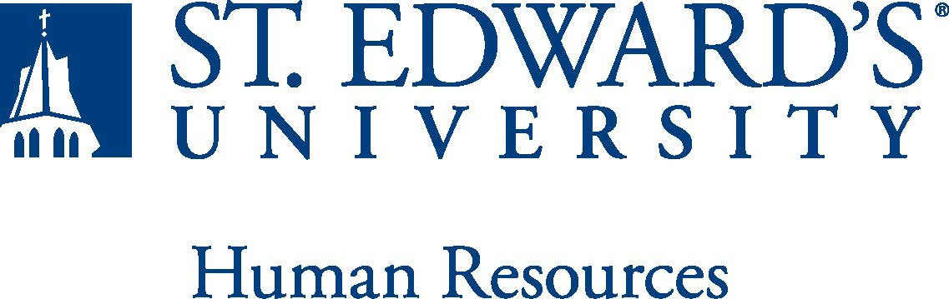

Job Title: 12 Month – Academic Success Coach | FLSA Classification: (FLSA Federal Law GUIDELINES)  - Exempt ☐Nonexempt
Reports to: Associate Director | Location:
Department: Academic Counseling and Support Programs | Division:
Employment Category:  - Full-Time ☐ Part-Time | Paygrade: 414
PRIMARY PURPOSE OF POSITION

Academic Success Coaches currently serve all first-year students, either freshmen or transfer students. In subsequent years, Success Coaches will work with all undergraduate students. As a member of a larger staff, the Success Coach supports student development in the Holy Cross tradition. The Success Coach provides customized, holistic, and proactive academic advising and case-management services to positively influence the student’s experience, as well as student retention, persistence, graduation rates, and post-graduation opportunities.
ESSENTIAL DUTIES AND RESPONSIBILITIES
- Coach and advise students throughout their undergraduate experience with their faculty advisor/mentor.
- Advise students individually and/or in groups regarding general education requirements, appropriate class selection, campus resources, academic policies and procedures.
- Enhance relationships with students, staff and faculty to support enrollment, persistence and success. Support students by helping them achieve their goals and invest in themselves.
- Develop supportive, proactive relationships and serve as the main point of contact for each student.
- Meet individually with students in the cohort on a regular basis to develop individualized success plans.
- Challenge, support and counsel them as they navigate college life at the institution.
- Monitor the success and progress of each student in the cohort and provide pertinent student services as needed.
- Assist in the planning, creation, expansion, implementation, and evaluation of the Academic Success Coach program.
- Coordinate and execute student programming related to student success for members of the cohort.
- Provide a trusting relationship where students can share their thoughts, aspirations, concerns, and interests. Provide students with the available resources to aid with their academic success
- Support enrollment, student development and retention services while ensuring high-quality learning.
- Other duties as assigned.

QUALIFICATIONS

Bachelor’s degree required, Master's degree preferred. Two or more years in social services, education field, higher education to include; admissions, student affairs, advising, counseling or related areas required. Experience in student mentoring, tutoring, supplemental instruction, freshman transition issues, and working with students with academic challenges. Must possess the ability to successfully pass a criminal background check.
WORKING CONDITIONS
This is a 12-month exempt position and your expected work schedule is Monday through Friday. As an exempt employee your schedule may vary based on the number of hours needed to meet the job responsibilities. The individual holding this position may need to be available early morning, evening, and weekends to meet the needs of the department.
PHYSICAL REQUIREMENTS
The expectations listed below are representative of the abilities that may be needed to fulfill duties of this position. Reasonable accommodations may be made to enable individuals with disabilities to perform the essential functions. Physical strength/endurance to enable him/her to perform/participate in the following activities:
- Physically able to lift various materials up to 50 pounds on an occasional basis.
- While performing required job tasks, physically able to bend, crouch and reach continuously.
- While performing required job tasks, physically able to climb stairs, ladders or scaffolding as necessary.
- While performing required job tasks, physically able to remain seated, frequently to continuously.
- Possesses dexterity abilities required to perform typing, operate a computer and other office equipment, to perform filing, and related job responsibilities and attention to detail competence.
- Physically able to spend significant time reading both on paper and on a computer.
- Ability to travel by car and plane for University business. Ability to drive.
SUPERVISORY RESPONSIBILITIES
SUPERVISION RECEIVED: General supervision is provided by the Associate Director.

SUPERVISION EXERCISED: Functional supervision is provided to student workers.
EXPECTATIONS

The incumbent is expected to have or possess:
- Ability to work collaboratively as a team with both the student and the faculty advisor/ mentor in their major.
- Ability to inspire, motivate, and challenge students of all cultures.
- Possess a thorough understanding of university policies, procedures, requirements, and effectively communicate them to students.
- Maintain connections with faculty and staff across campus, especially, but not limited to the Office of First Year Experience, Academic Success Center, Undergraduate Admissions, Office of Student Financial Aid, Office of Scholarships, Residential Life, Special Services, and other offices as needed.
- Flexible in Work: ability to be nimble when working with students, faculty, colleagues and administration.
- Ability to work hard with positive energy, seizing opportunities to accomplish and exceed goals.
- Ability to be customer focused: dedicated to student development and success, establishes and maintains effective relationships with students and faculty to earn their trust and respect, possesses exceptional counseling, coaching, and mentoring skills.
- Ability to possess integrity & trust: widely trusted, truthful, admits mistakes, keeps confidences and can present the truth in an appropriate and helpful manner.
- Ability to possess listening skills: can accurately restate the opinions of others, practices attentive and active listening, while exhibiting patience for others.
- Ability to handle highly confidential material, understanding that all University information should only be disclosed to others who have a need to know, for legitimate business reasons. Have the ability to exercise and apply sound judgment and decision making skills as well as the ability to maintain integrity and confidentiality of data.
- Has advanced knowledge of Microsoft Office and Google Suite software programs. Ability to quickly learn new technology and is self-motivated to stay current with emerging technologies.
- Ability to edit work for spelling and grammar, present numerical data effectively and is able to read and interpret written information. Demonstrates accuracy and thoroughness and monitors own work to ensure quality.
- Ability to possess excellent communication, organizational, problem- solving skills.
- Adapt to change in the work environment, manage competing demands and able to deal with frequent change, delays or unexpected events.
- Ability to accept supervision, assignments, change and correction. Proven effectiveness in dealing with a wide range of professionals, staff, and administrators.
- Ability to balance priorities to accomplish assigned tasks within the required time frame and be able to shift quickly between several tasks without loss of continuity.
- Engage in meaningful and intentional professional development appropriate for areas of responsibility and actively engage in personal and campus well-being initiatives.
- Carry out all responsibilities and objectives in professional manner.
- Accept and render constructive criticism in a professional manner.
- Flexible in Work: ability to be nimble when working with students, faculty, colleagues and administration
- Ability to develop knowledge of, respect for, and skills to engage with those of other cultures or backgrounds in accordance with the Holy Cross Mission.
- Adhere to the policies and procedures established by St. Edward's University.

This document describes the general purpose, duties and essential functions associated with this job and is not an exhaustive list of all duties that may be assigned or skills that may be required.
I have read and understand my job description and acknowledge that management reserves the right to change or reassign job duties or combine jobs at any time.

Employee (Print Name): Date:

Employee (Signature): Date:

 | HR OFFICE USE ONLY:
Approved by: |  | Signature of the person with the authority to approve the job  description
Printed Name of  Approver: |  | Printed name of the person with the authority to approve the job  description.
Date  approved: |  | Date upon which the job description was approved
Reviewed: |  | Date when the job description was last reviewed

