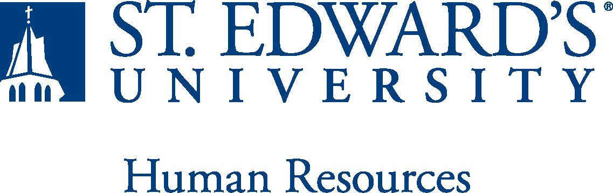

Job Title: Director of Sports Information | FLSA Classification:  ☒Exempt ☐Nonexempt
Reports to: Associate Vice President for Athletics | Location: Recreation and Athletics Center
Department: Athletics | Division: Student Affairs
Employment Category:  ☒Full-Time ☐ Part-Time | Paygrade: 416
PRIMARY PURPOSE OF POSITION

The sports information director will be responsible for the direction of a comprehensive communications program by coordinating sports information, social media initiatives, public relations and marketing for St. Edward’s University Athletics with an emphasis on celebrating student-athletes’ and coaches’ endeavors and accomplishments. As a member of NCAA DII and the Lone Star Conference, St. Edward’s supports 10 competitive NCAA DII programs and a non-NCAA competitive Esports program.
The sports information director will operate such that the overall quality and integrity of the department aligns with the university’s vision of excellence, while promoting a positive and productive working relationship with other staff members.
ESSENTIAL DUTIES AND RESPONSIBILITIES
- Coordinate the following for each of the sport programs:
  - Game day statistics (gather, maintain, report to conference, NCAA, etc.), broadcast productions, programs, photography, etc.
  - Promotion of attendance in collaboration with the assistant athletics director of operations
  - Content for social media and other video purposes (weekly video highlights, end of year highlights etc.)
  - Nominations for honors and awards for student-athletes and coaches
  - Game notes and press release for each contest, award, community service event, etc. and pitch news stories to media
  - Respond to and manage media requests, interviews, news conferences and photo sessions.
  - Maintain historical records, statistics and photographs among other important department information
  - Travel to post season tournaments
- Manage home event web stream broadcasts; operating and staffing
- Provide event coverage and game-day management functions
- Provide oversight of the athletics web site
- Develop and manage social media strategy for the university's athletics programs
  - Create and maintain a social media calendar for both short-term initiatives and long-term campaigns
  - Oversee writing, producing, and editing digital audio and video promotional material and devise best practices for incorporating a multimedia presence into SEU Athletics' social media platforms
  - Manage and maintain monitoring and analytics systems to track social media engagement and results
- Oversee St. Edward's multimedia platforms - develop and execute video content including game highlights, feature stories, season previews and other content
- Maintain athletic photography image bank
- Provide media coverage for athletics department events not specific to a particular sport program
- Serve as official spokesperson for the university's athletics programs
- Coordinate media and public relations efforts for the university's athletics programs
- Serve as the direct liaison between Athletics and the University Marketing and Communications offices
- Knowledge of grammar, composition, and AP style
- Oversee licensure of university athletics marks – diligently promote, enhance and protect the brand reputation
- Work collaboratively in the planning and preparation of the Athletics Hall of Fame selection process through data collection, management of nominee list and annual selection
- Hire and supervise student worker / intern staff (undergraduate and graduate)
- Work actively toward accomplishing the University long range plan and serve on campus-wide committees
- Other duties as assigned

QUALIFICATIONS
- Required:
  - Bachelor's degree from an accredited college or university.
  - Two or more years of related work experience.
  - Knowledge of NCAA rules and regulations as they pertain to athletics communications.
  - Proficiency with Adobe Creative Suite, Microsoft Office, and video editing.
  - An understanding of print and electronic media, to include web site maintenance and social media strategies.
  - Strong organizational, interpersonal, problem-solving, creative thinking, communication and written skills.
  - High motivation with a capacity for independent work within the context of an intensely goal-oriented environment.
  - A demonstrated commitment to diversity, equity, inclusion, and student success as well as working with broadly diverse communities.
  - An unencumbered driver's license and the ability to successfully pass a criminal background check.
- Preferred:
  - Master’s degree in Sports Administration, Communication, Recreation Management or Journalism.
  - Four or more years of experience as an Athletics Communications staff member or graduate assistant for a college athletic department or conference office.
  - Two years of supervision.
  - Proficiency in NCAA approved statistical procedures to include StatCrew software and NCAA LiveStats.
  - Experience using Sidearm Sports website provider.
  - Advanced knowledge and understanding of various social media platforms, including Facebook, Twitter, Instagram, TikTok, and YouTube.
  - Experience communicating institutional messages to the public through external media web and social media channels.

WORKING CONDITIONS
The individual holding this position must
- have the flexibility to work long, irregular hours to included evening, weekend and holiday hours to meet the needs of the department, in an overall balanced work week and year.
- be able to tolerate exposure to indoor/outdoor environments/climate changes.
PHYSICAL REQUIREMENTS
The expectations listed below are representative of the abilities that may be needed to fulfill duties of this position. Reasonable accommodations may be made to enable individuals with disabilities to perform the essential functions. Physical strength/endurance to enable him/her to perform/participate in the following activities:
- Physically able to lift various materials up to 30 pounds on an occasional basis.
- While performing required job tasks, frequent walking as well as sitting for extended periods of time.
- Possesses dexterity abilities required to perform typing, operate a computer and other office equipment.
- Ability to travel by car and plane for University business.

SUPERVISORY RESPONSIBILITIE
Student workers.
EXPECTATIONS

The incumbent is expected to have or possess:
- Strong organizational and time-management skills.
- Highly effective verbal and written communications skills.
- Excellent interpersonal skills, including collaboration, relationship building, and ability to respond positively and flexibly when working with all levels in the organization and with outside parties.
- Ability to work with student-athletes and coaches and should be comfortable speaking to groups of various sizes.
- Knowledge of NCAA and LSC rules and regulations.
- Ability to effectively communicate with all visiting teams, officials, and part-time staff and provide them with detailed instruction for their arrivals.
- Ability to act as the primary liaison for the athletic department to troubleshoot and solve any issues or problems that arise throughout the events
- Understanding of St. Edward’s University’s mission and goals.
- Ability to exercise and apply sound judgment and decision-making skills as well as the ability to maintain integrity and confidentiality of data.
- Advanced knowledge of Microsoft Office and Google Suite software programs. Ability to quickly learn new technology and be self-motivated to stay current with emerging technologies.
- Ability to edit work for spelling and grammar, present numerical data effectively and read and interpret written information. Demonstrate accuracy and thoroughness and monitor own work to ensure quality.
- Ability to adapt to change in the work environment, manage competing demands and deal with frequent change, delays or unexpected events.
- Ability to accept supervision, assignments, change and correction.
- Proven effectiveness in dealing with a wide range of professionals, staff and administrators.
- Ability to balance priorities to accomplish assigned tasks within the required time frame and to shift quickly between several tasks without loss of continuity.
- Ability and desire to be a strong team player and develop team dynamics within the athletics staff
- Ability and desire to engage in meaningful and intentional professional development appropriate for areas of responsibility and actively engage in personal and campus well-being initiatives.
- Ability to carry out all responsibilities and objectives in professional manner.
- Ability to accept and render constructive criticism in a professional manner.
- Ability to develop knowledge of, respect for, and skills to engage with those of other cultures or backgrounds in accordance with the Holy Cross Mission.
- Ability to follow the policies and procedures established by St. Edwards University, Lone Star Conference and the NCAA.

This document describes the general purpose, duties and essential functions associated with this job and is not an exhaustive list of all duties that may be assigned or skills that may be required.

I have read and understand my job description and acknowledge that management reserves the right to change or reassign job duties or combine jobs at any time.

Employee (Print Name): Date:

Employee (Signature): Date:

 | HR OFFICE USE ONLY:
Approved by: |  | Signature of the person with the authority to approve the job  description
Printed Name of  Approver: |  | Printed name of the person with the authority to approve the job  description.
Date  approved: |  | Date upon which the job description was approved
Reviewed: |  | Date when the job description was last reviewed

