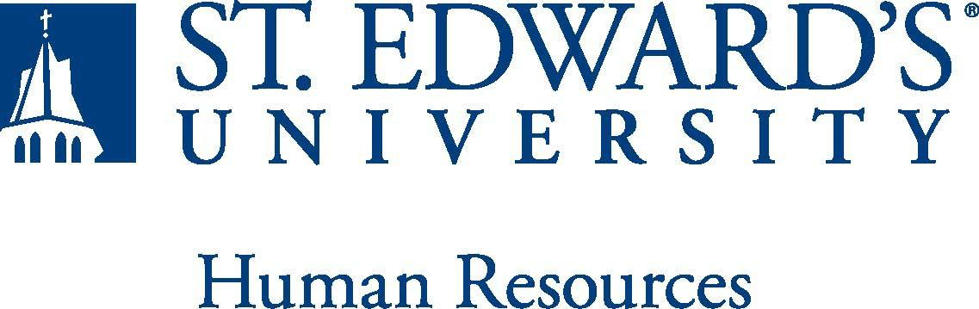

Job Title:  Admission Campus Visits Coordinator | FLSA Classification:  - Exempt X Nonexempt
Reports to:  Associate Director of Admission Visit Programming | Location:  On-Campus (Main Building, Room 100A)
Department: Admission | Division: Enrollment Management
Employment Category:  X Full-Time ☐ Part-Time | Paygrade:

PRIMARY PURPOSE OF POSITION
Responsible for supporting the Admission Campus Visits Manager to make sure successful visit programs are executed to assist the Office of Admission in reaching enrollment and recruitment goals. This administrative position is responsible for supporting multiple strategic recruitment visit initiatives and representing the university to prospective students, families, external vendors, and campus partners. This task-oriented position provides logistical and personnel support for all recruitment events.

ESSENTIAL DUTIES AND RESPONSIBILITIES
• Ensures that front desk operations, admissions appointments, recruitment events, and travel calendars are properly planned and assigned for all admissions staff, graduate assistants, and student workers. Monitor the scheduling and set-up of the Admission Welcome Center. Support the Admission Campus Visits Manager with event coordination and planning
• Represent the university and Office of Admission in a variety of communication contexts (email, presentations, writing, over the phone, etc.).
• Execute administrative tasks that facilitate the travel incentive program, overnight accommodations for guests, airport shuttles reservations.
• Work with student staff to process campus visits, such as personalized comprehensive visits and group tours for visiting high schools.
• Facilitates a work environment that encourages knowledge of, respect for, and the development of skills to engage with those of other cultures or backgrounds.
• Monitor and assist with on-going, complex registration details for multiple events, simultaneously.
• Set up information session programs that support graduate and transfer recruitment goals. • Develops programming for recruitment events and implements tools to measure outcomes designed to impact enrollment behaviors for prospective students.
• Support the Admission Campus Visits Manager with event coordination and planning.
• Other duties as assigned.
QUALIFICATIONS
Bachelor's degree and/or at least one year of experience in event planning and/or high-level customer service. Work as part of a team and the capacity to successfully manage interpersonal relationships with effective communication are critical skills. Must be able to effectively and collaboratively communicate with a diverse audience, including parents, students, and faculty and enjoy working in a college environment. Must be available for weekend, before-8a.m., and after 5p.m. work throughout the year. Must possess the ability to successfully pass a criminal background check.

Must be available for weekend, before-8a.m., and after 5p.m. work throughout the year for special events.
WORKING CONDITIONS
PHYSICAL REQUIREMENTS
The expectations listed below are representative of the abilities that may be needed to fulfill the essential functions of this position. Reasonable accommodations may be made to enable individuals with disabilities to perform the essential functions. Physical strength/endurance to enable him/her to perform/participate in the following activities:

- Physically able to lift various materials up to 25 pounds on an occasional basis.
- While performing required job tasks, physically able to bend, crouch and reach continuously.
- While performing required job tasks, physically able to remain seated, frequently to continuously.
- While performing required job tasks, physically able to remain standing up to 15% of the time.
- Possesses dexterity abilities required to operate a computer and other office equipment to perform related job responsibilities.

General supervision over student workers.
SUPERVISORY RESPONSIBILITIES
EXPECTATIONS

The incumbent is expected to have or possess:

• Ability to handle highly confidential material, understanding that all University information should only be disclosed to others who have a need to know, for legitimate business reasons. Have the ability to exercise and apply sound judgment and decision making skills as well as the ability to maintain integrity and confidentiality of data.
• Able to effectively communicate general information to University constituencies, however, some situations may require the ability to relay complex or adverse information with tact and diplomacy.
• Knowledge of federal, state, and college regulations that govern the administration of the financial aid programs, and ability to use tools in conjunction with databases.
• Proficient in the use of Microsoft Office software (specifically, Word and Excel) as well as the ability to stay current with emerging office technologies.
• Ability to demonstrate strong organizational skills with the utmost attention to detail.
• Ability to display an enthusiastic personality with an affinity for teamwork and collaboration and a desire to support the team in achieving comprehensive goals.
• Initiate and answer telephone calls; screen and direct calls.
• Ability to accept supervision, assignments, change and correction.
• Proven effectiveness in dealing with a wide range of professionals, staff, and administrators.
• Ability to balance priorities to accomplish assigned tasks within the required time frame and to be able to shift quickly between several tasks without loss of continuity.
• Engage in meaningful and intentional professional development appropriate for areas of responsibility.
• Carry out all responsibilities and objectives in a professional manner.
• Maintain professionalism when dealing with all staff and other customers while fostering positive working relationships.
• Accept and render constructive criticism in a professional manner.
• The ability to develop knowledge of, respect for, and skills to engage with those of other cultures or backgrounds in accordance with the Holy Cross Mission.
• Adhere to the policies and procedures established by St. Edward's University.

