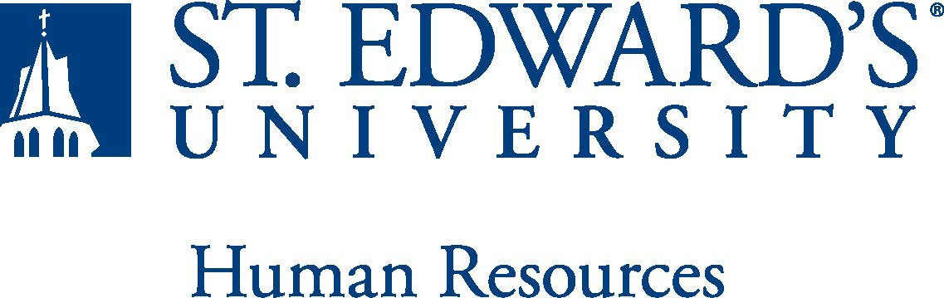

Job Title: The formal title of the position  Visiting Instructor or Visiting Assistant Professor of Religious and Theological Studies | FLSA Classification:  Exempt
Reports to: Title of the position that the job incumbent reports to  Dean Sharon Nell | Location: AHMX
Department: Religious and Theological Studies | Division: AHMX
Employment Category:  Full-Time | Paygrade: 615
PRIMARY PURPOSE OF POSITION

The position is a one-year replacement for a faculty member on leave. The person in this position will be expected to teach survey courses such Introduction to Catholicism and Basic Christian Questions. Candidates should also be prepared to contribute upper level seminars on Sacraments OR Christian Spirituality and the Catholic Intellectual Tradition. The person will also have responsibilities within the department of Religious and Theological Studies and will as well be asked to contribute to and support diversity at St. Edward's University.

ESSENTIAL DUTIES AND RESPONSIBILITIES
Teach 4 courses per semester, including courses fulfilling general education requirements and courses in the Religious and Theological Studies major/minor.
Participate in planning and implementing the departmental (i.e. Religious and Theological Studies) goals and assessments.
Participate in departmental, School of Arts and Humanities and University events and committee assignments.
Fulfill other required faculty responsibilities as outlined in the Faculty Manual.

QUALIFICATIONS
A Ph.D. or ABD status (dissertation work for the doctoral degree underway with master's degree attained) required in Theology, Religious Studies, or in a related area.
Demonstrated effective teaching at the undergraduate level required.
A record of (or evidence of the potential for) professional involvement and publication.
Educational philosophy consistent with a liberal arts emphasis and the mission of St. Edward's University.
Successful completion of an employment and criminal history background check required.
WORKING CONDITIONS

SCHEDULE: This is an exempt position and full-time, 9 months, to begin in the Fall 2022. The expected work schedule is Monday through Friday. As an exempt employee your schedule may vary based on the number of hours needed to meet the job responsibilities. The individual holding this essential services position will need to be available early morning, evening and occasionally on weekends to meet the needs of the University.

PHYSICAL REQUIREMENTS: Physical strength/endurance to enable him/her to perform/participate in the following activities:
PHYSICAL REQUIREMENTS
- While performing required job tasks, physically able to bend, crouch and reach continuously.
- While performing required job tasks, physically able to remain seated, frequently to continuously.
- While performing required job tasks, physically able to remain standing up to 15% of the time.
- Possesses dexterity abilities required to operate a computer and other office equipment to perform related job responsibilities.
SUPERVISORY RESPONSIBILITIES
SUPERVISION RECEIVED: General administrative direction from the Chair, Department.

SUPERVISION EXERCISED: None
EXPECTATIONS

The incumbent is expected to have or possess:
- Have the ability to exercise and apply sound judgment and decision-making skills as well as the ability to maintain integrity and confidentiality of data.
- Demonstrates a commitment to maintaining academic programs of distinction serving a variety of students and holds an educational philosophy consistent with a liberal arts emphasis of the lifelong learner and St. Edward’s Mission Statement.
- Plays an active role in the maintenance of academic standards and in the development of educational policy and of curriculum areas within the discipline including the development of pedagogical material.
- Has knowledge of instructional/educational methods and techniques. Coordinate, plan, organize, and instruct courses as assigned.
- Have the ability to teach the course material in ways that maximize student learning.
- Employ appropriate teaching and learning strategies to communicate subject matter to students.
- Utilize available instructional technology, i.e. learning management system, the internet and other interactive technology, when appropriate.
- Create a learning environment that is safe, respectful and interesting as well as fair for students from various cultural backgrounds, gender identities, races, ability levels, and developmental needs. Leads rigorous, inquiry-based learning tasks to engage students in deep content exploration as well as the habits of scholarship.
- Fosters creative thinking, reasoning and problem-solving skills.
- Solid knowledge of Microsoft Office, on-line teaching modalities and have the self-motivation and the ability to stay current with emerging office technologies.
- Exemplary communication skills, including dealing effectively with the students, faculty, staff, and general public, in person, over the telephone, or via electronic forms of communication.
- Ability to establish and maintain effective working relationships with associates, colleagues, students and members of the University staff.
- Ability to relate professionally and positively in a stressful environment.
- Possess the ability to communicate accurate information related to curriculum, academic and operational policies and procedures.
- Strong organizational skills and the ability to work well under pressure and to meet deadlines. Ability to successfully manage multiple projects and organize special events as assigned. Able to effectively coordinate activities and schedules.
- Confer regularly with immediate supervisor, other department/University personnel, and/or various firms/organizations/individuals external to the University to exchange information and resolve problems.
- Ability to balance priorities to accomplish assigned tasks within the required time frame and to be able to shift quickly between several tasks without loss of continuity.
- Engage in meaningful and intentional professional development appropriate for areas of responsibility.
- Carry out all responsibilities and objectives in a professional manner.
- Maintain professionalism when dealing with all staff and other stakeholders while fostering positive working relationships.
- Accept and render constructive criticism in a professional manner.
- Ensures to follow and adhere to all policies and procedures established by St. Edwards University.

This document describes the general purpose, duties and essential functions associated with this job and is not an exhaustive list of all duties that may be assigned or skills that may be required.
I have read and understand my job description and acknowledge that management reserves the right to change or reassign job duties or combine jobs at any time.

Employee (Print Name): Date:

Employee (Signature): Date:

 | HR OFFICE USE ONLY:
Approved by: |  | Signature of the person with the authority to approve the job  Description
Printed Name of  Approver: |  | Printed name of the person with the authority to approve the job  description.
Date  approved: |  | Date upon which the job description was approved
Reviewed: |  | Date when the job description was last reviewed

