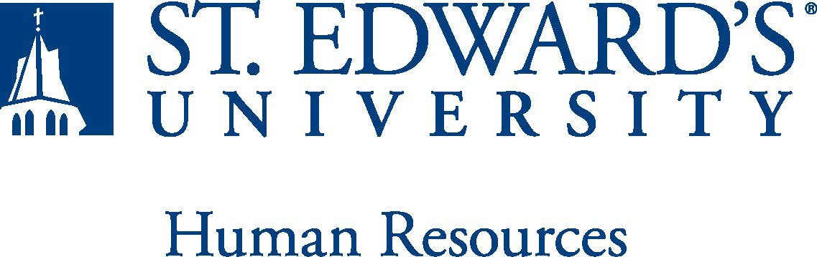

Job Title: 12 Month – Academic Success Coach | FLSA Classification: (FLSA Federal Law GUIDELINES)  - Exempt ☐Nonexempt
Reports to: Associate Director | Location:
Department: Academic Counseling and Support Programs | Division:
Employment Category:  - Full-Time ☐ Part-Time | Paygrade: 414
PRIMARY PURPOSE OF POSITION

Academic Success Coaches currently serve all types undergraduate students: first-year, transfer, continuing & reentering students. As a member of a larger staff, the Success Coach supports student development in the Holy Cross tradition. The Success Coach provides customized, holistic, and proactive academic advising and case-management services to positively influence the student’s experience, as well as student retention, persistence, graduation rates, and post-graduation opportunities.
ESSENTIAL DUTIES AND RESPONSIBILITIES
Coaching/Advising
- Coach and advise students throughout their undergraduate experience in conjunction with their faculty advisor/mentor.
- Advise students individually and/or in groups regarding general education requirements, appropriate class selection, degree requirements campus resources, academic policies and procedures.
- Develop supportive, proactive relationships that allow the coach to challenge, support and counsel the student, as the main point of contact for them as they navigate college life at the institution.
- Provide a trusting relationship where students can share their thoughts, aspirations, concerns, and interests. Provide students with the available resources to aid with their academic success
- Maintain connections with faculty and staff across campus, especially, but not limited to the Student Success Center, Undergraduate Admissions, Student Financial Services, Residence Life.
- Enhance relationships with students, staff and faculty to support enrollment, persistence and success. Support students by helping them achieve their goals and invest in themselves.

Administrative & Retention
- Monitor the success and progress of each student in the cohort and provide pertinent student services and information to the retention team as needed.
- Manage caseload of students year-round, including but not limited to: creation and maintenance of individualized degree plans, detailed notes both for degree planning and coaching, tracking retention and persistence predictions for students.
- Assist in the planning, creation, expansion, implementation, and evaluation of the Academic Success Coach program.
- Coordinate and execute student programming related to student success for members of the cohort.
- Ability to balance priorities to accomplish assigned tasks within the required time frame and be able to shift quickly between several tasks without loss of continuity.
- Ability to handle highly confidential material, complying with FERPA. Have the ability to exercise and apply sound judgment and decision-making skills as well as the ability to maintain integrity and confidentiality of data.
- Support enrollment, student development and retention services while ensuring high-quality learning.

Other duties as assigned.

QUALIFICATIONS

Bachelor’s degree required, Master's degree preferred. Experience in higher education to include; admissions, student affairs, advising, counseling or related areas required. Experience in student mentoring, tutoring, supplemental instruction, freshman transition issues, and working with students with academic challenges. Must possess the ability to successfully pass a criminal background check.
WORKING CONDITIONS
This is a 12-month exempt position and your expected work schedule is in person Monday through Friday 8-5. As an exempt employee your schedule may vary based on the number of hours needed to meet the job responsibilities. The individual holding this position may need to be available early morning, evening, and weekends to meet the needs of the department.
PHYSICAL REQUIREMENTS
The expectations listed below are representative of the abilities that may be needed to fulfill duties of this position. Reasonable accommodations may be made to enable individuals with disabilities to perform the essential functions. Physical strength/endurance to enable him/her to perform/participate in the following activities:
- Physically able to lift various materials up to 50 pounds on an occasional basis.
- While performing required job tasks, physically able to bend, crouch and reach continuously.
- While performing required job tasks, physically able to climb stairs, ladders or scaffolding as necessary.
- While performing required job tasks, physically able to remain seated, frequently to continuously.
- Possesses dexterity abilities required to perform typing, operate a computer and other office equipment, to perform filing, and related job responsibilities and attention to detail competence.
- Physically able to spend significant time reading both on paper and on a computer.
- Ability to travel by car and plane for University business. Ability to drive.
SUPERVISORY RESPONSIBILITIES
SUPERVISION RECEIVED: General supervision is provided by the Associate Director.

SUPERVISION EXERCISED: Functional supervision is provided to student workers.
EXPECTATIONS

Honor the values in the operating principles for St. Edward’s University:
- Work through collaboration: address concerns from a university-wide perspective, share information and meet deadlines; give and receive constructive feedback, listen with an open mind.
- Treat each other respectfully: speak to each other in professional and respectful tone; maintain composure and judgment under the pressure caused by differences, actively listen for understanding, clarify confusion, affirm feelings, and seek mutually beneficial solutions.
- Continually develop organization & take responsibility for excellence: commit to continuous assessment of the needs of students and take responsibility for continual analysis of policies, procedures, processes, as well as the individual’s own performance, to ensure effective and efficient work is always possible.
- Dedicated to high a standard of service: creative problem-solving skills, respond quickly, considerately, and correctly to the needs of those who need help. Continually work to increase job knowledge and knowledge about other areas of the university, and improve service. Willing to place higher priority on service than on administrative ease; politeness, cheerfulness, and helpfulness are valued and expected.
- Open communication: offer and accept suggestions for improvement, and be receptive to others' ideas and to changes related to continual assessment. Work to create the trust that makes open and direct communication possible.
- Understand and promote diversity: support the ideal of equal and open access to opportunity for everyone. Work to critically examine beliefs, biases, and assumptions that may create division and misunderstanding about ethnicity, gender, age, sexual orientation, values, religion, politics, disabilities, socio-economic status, attitudes, language, and all other differences.

This document describes the general purpose, duties and essential functions associated with this job and is not an exhaustive list of all duties that may be assigned or skills that may be required.
I have read and understand my job description and acknowledge that management reserves the right to change or reassign job duties or combine jobs at any time.

Employee (Print Name): Date:

Employee (Signature): Date:

 | HR OFFICE USE ONLY:
Approved by: |  | Signature of the person with the authority to approve the job  description
Printed Name of  Approver: |  | Printed name of the person with the authority to approve the job  description.
Date  approved: |  | Date upon which the job description was approved
Reviewed: |  | Date when the job description was last reviewed

