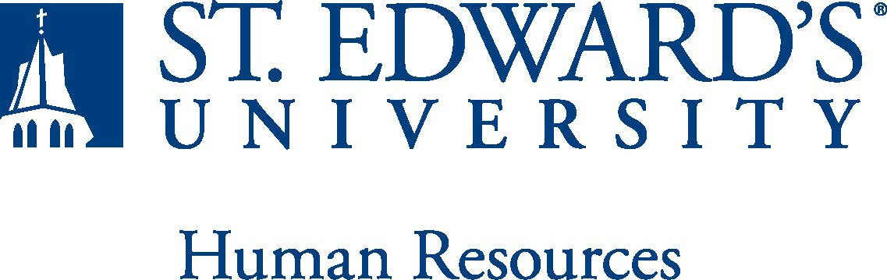

Job Title: The formal title of the position  Conduct Coordinator | FLSA Classification:  x Exempt ☐Nonexempt
Reports to: Title of the position that the job incumbent reports to  Associate Dean of Students/Director of Student Conduct | Location:  Main Building Suite G16
Department: Dean of Students | Division: Student Affairs
Employment Category:  xFull-Time ☐ Part-Time | Paygrade:
PRIMARY PURPOSE OF POSITION

The Conduct Coordinator provides case management and intervention for students identified as at risk for violating the Code of Student Conduct. This role will live on campus, work with the Dean of Students Office and participate in the after-hours on-call rotation to support students in need of afterhours conduct and welfare assistance. The Conduct Coordinator will also assist the Dean of Students Office in training community members about our processes related to conduct, case management, intervention and follow-up. Additionally, this position will provide outreach and consultation to the campus community (students, faculty, and staff) and will work very closely with other university personnel.

ESSENTIAL DUTIES AND RESPONSIBILITIES

- Serve as contact for campus partners who have concerns about student behaviors, both in and outside of the classroom.
- Conduct educational conversations with students who may be acting behaviorally in ways that are detrimental to our community.
- Develop, implement, and support interventions, sanctions, and response plans to student behavioral concerns.
- Assist in maintaining and managing student information and records in Maxient, to include the timely processing and assigning of reports and maintaining online files related to student follow-up; utilizing a database system and provide hard copy reports as needed.
- Serve as an investigator and assist on going case management of cases of sexual or gender-based violence, harassment, and discrimination.
- Prepare and participate with the creation of content for the training of other departments, organizations, students, and community partners to provide information concerning behavioral concerns, philosophy, process and purpose of the conduct system , and prevention programming that include online offerings.
- Assist the Dean of Students Office in identifying and working with students who are late in completing conduct sanctions.
- Serve in the on-call rotation after hours and on weekends.

QUALIFICATIONS
Graduation from a four-year college or university. Preferred Master’s in progress or completed Master’s degree in a related field. Two to four years of directly related experience working with the young adult population. Knowledge of and previous experience with confidentially of diverse populations (language, culture, race, age, economic status, etc.) and multicultural issues. Working knowledge of principles of de-escalation and mediation methods and training. Knowledge/training in multicultural issues and the ability to work in a diverse community. Working knowledge FERPA, Clery, and Title IX. Preferred training or experience working in a university setting. Experience is preferred in developing/implementing/assessing prevention programming activities. Excellent interpersonal communications skills-in person, in writing, and via technology. Highly developed organizational and time management skills. Ability to work congruently within the mission of the university, division and department. Must possess the ability to successfully pass a criminal background check.
WORKING CONDITIONS
This is a 12-month live-in position. Generally, the hours for this position are Monday through Friday, 9:00am – 5pm, but this position is a part of our on-call rotation that works occasional nights and weekends throughout the year.
PHYSICAL REQUIREMENTS
The expectations listed below are representative of the abilities that may be needed to fulfill duties of this position. Reasonable accommodations may be made to enable individuals with disabilities to perform the essential functions. Physical strength/endurance to enable him/her to perform/participate in the following activities:
- Physically able to lift various materials up to 25 pounds on an occasional basis.
- While performing required job tasks, physically able to bend, crouch and reach continuously.
- While performing required job tasks, physically able to remain seated, frequently to continuously.
- While performing required job tasks, physically able to remain standing up to 15% of the time.
- Possesses dexterity abilities required to operate a computer and other office equipment to perform related job responsibilities.
SUPERVISORY RESPONSIBILITIES
Potential supervision over student workers.
EXPECTATIONS

The incumbent is expected to have or possess:
- Ability to handle highly confidential material, understanding that all University information should only be disclosed to others who have a need to know, for legitimate business reasons. Have the ability to exercise and apply sound judgment and decision making skills as well as the ability to maintain integrity and confidentiality of data.
- Has advanced knowledge of Microsoft Office and Google Suite software programs. Ability to quickly learn new technology and is self-motivated to stay current with emerging technologies.
- Adapt to change in the work environment, manage competing demands and able to deal with frequent change, delays or unexpected events.
- Ability to comply with workplace guidelines and attendance requirements.
- Ability to accept supervision, assignments, change and correction. Proven effectiveness in dealing with a wide range of professionals, staff, and administrators.
- Ability to balance priorities to accomplish assigned tasks within the required time frame and be able to shift quickly between several tasks without loss of continuity.
- Carry out all responsibilities and objectives in professional manner.
- Accept and render constructive criticism in a professional manner.
- The ability to develop knowledge of, respect for, and skills to engage with those of other cultures or backgrounds in accordance with the Holy Cross Mission.
- Adhere to the policies and procedures established by St. Edwards University.

This document describes the general purpose, duties and essential functions associated with this job and is not an exhaustive list of all duties that may be assigned or skills that may be required.

