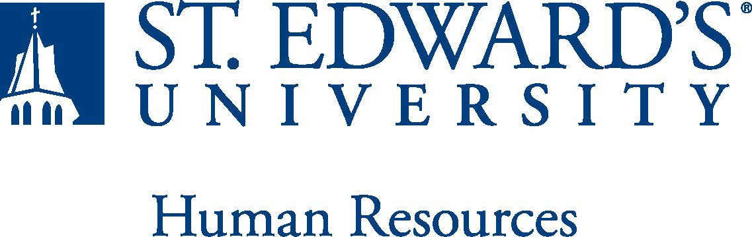

Job Title: The formal title of the position  Director of Recreation and Wellness | FLSA Classification:  X Exempt ☐Nonexempt
Reports to: Title of the position that the job incumbent reports to  Associate Vice President for Student Affairs | Location:  Alumni Gym
Department: Recreation and Wellness | Division: Student Affairs
Employment Category:  X Full-Time ☐ Part-Time | Paygrade: 418
PRIMARY PURPOSE OF POSITION

The Director of Recreation and Wellness will provide leadership in the development and management of a well-organized department that places a premium on wellbeing for students and employees. The Director will manage the day to day aspects of the Recreation and Wellness department which include staff and student staff supervision, training, and support, budget management, and development of and execution on a focused set of annual goals that support department, Division, and University priorities.
ESSENTIAL DUTIES AND RESPONSIBILITIES

- Oversee all operations and planning of comprehensive Recreation and Wellness program including but not limited to Intramural Sports, Informal Recreation, Wellness and Outreach, Fitness, Club Sports, Instructional programs, Student Development, Outdoor Adventures, and capital projects.
- Provide fundraising/resource development support for the Division of Student Affairs and in alignment with the University Advancement Office.
- Coordinate recruitment, selection, training, evaluation of full-time professional and paraprofessional student Recreation & Wellness staff, including facility personnel, intramural sports staff and officials, Group Fitness class instructors, personal trainers, club sport supervisors, outdoor trip leaders, and marketing paraprofessional(s).
- Provide strategic vision that promotes diversity, equity, and inclusion, and meets the needs of users, and promotes healthy lifestyles.
- Assess program learning outcomes and their connection to retention, student leadership development, and student satisfaction.
- Manage LIVEWELLSEU/Recreation & Wellness marketing plans including web, print, and digital media presence.
- Construct department short and long term goals and initiatives to align with University and divisional strategic plans.
- Provide oversight for annual budget including student staff wages, operations budget, and revenue.
- Maintain a strong commitment to student development and engagement.
- Coordinate management of program facilities including scheduling, revenue generation, customer service, staff development, scheduled maintenance, risk management, and goal setting.
- Liaison with university departments for collaborative and co-curricular programming.
- Work actively toward accomplishing the University strategic plan and serve on campus-wide committees.
- Other related duties.
Required:
QUALIFICATIONS
- Master’s degree in student affairs, education, higher education, health education or related field
- Four or more years of professional experience managing multiple university recreation and wellness programs (Fitness, Intramural Sports, Club Sports, Aquatics, Informal Recreation or Outdoor Recreation)
- Proven ability to manage, lead, and communicate with a diverse work group with a strong commitment to the academic achievement and personal growth of each student
- Possess strong interpersonal and written communication skills and be committed to the integration of co-curricular experiences in the overall educational programs of the university
- Working knowledge of computer applications relative to management of campus recreation
- Successful completion of an employment and/or criminal history background check required

Preferred:
- NIRSA and ACHA membership
- Certifications relative to program area: Lifeguard and/or Water Safety Instructor (Red Cross or equivalent), Certified Pool Operator, nationally recognized personal training and group fitness instruction certification (AFAA, NCSM, NASM preferred), CPR/AED/First Aid Instructor
WORKING CONDITIONS

This is a twelve-month, full-time position. The work schedule varies often and includes day, evening, and/or weekend hours.
PHYSICAL REQUIREMENTS

The expectations listed below are representative of the abilities that may be needed to fulfill the essential functions of this position. Reasonable accommodations may be made to enable individuals with disabilities to perform the essential functions. Physical strength/endurance to enable him/her/them to perform/participate in the following activities:

- Physically able to lift various materials up to 25 pounds on an occasional basis.
- While performing required job tasks, physically able to bend, crouch and reach continuously.
- While performing required job tasks, physically able to remain seated, frequently to continuously.
- While performing required job tasks, physically able to remain standing up to 15% of the time.
- Possesses dexterity abilities required to operate a computer and other office equipment to perform related job responsibilities.
SUPERVISORY RESPONSIBILITIES

This position will supervise 1-3 professional roles within Recreation and Wellness.
EXPECTATIONS

- Contributes to a work environment that encourages knowledge of, respect for, and development of skills to supervise, engage, serve and support those of all cultures, identities and backgrounds.
- The ability to develop knowledge of, respect for, and skills to integrate the University mission and Holy Cross values into Center programs and services.
- Ability to handle highly confidential material, understanding that all University information should only be disclosed to others who have a need to know, for legitimate business reasons.
- Ability to exercise and apply sound judgment and decision making skills as well as the ability to maintain integrity and confidentiality of data.
- Ability to quickly learn new technology and is self-motivated to stay current with emerging technologies.
- Ability to edit work for spelling and grammar, present numerical data effectively and is able to read and interpret written information. Demonstrates accuracy and thoroughness and monitors own work to ensure quality.
- Adapt to change in the work environment, manage competing demands and able to deal with frequent change, delays or unexpected events.
- Remains competent and current through self-directed professional reading, developing professional contacts with colleagues, attending professional development courses, and attending training and/or courses as required by the supervisor.
- Demonstrated ability and interest in growth and learning new skills.
- Ability to accept supervision, assignments, change and correction. Proven effectiveness in dealing with a wide range of professionals, staff, and administrators.
- Ability to balance priorities to accomplish assigned tasks within the required time frame and be able to shift quickly between several tasks without loss of continuity.
- Engage in meaningful and intentional professional development appropriate for areas of responsibility and actively engage in personal and campus wellbeing initiatives.
- Carry out all responsibilities and objectives in a professional manner.
- Accept and render constructive criticism in a professional manner.
- Adhere to the policies and procedures established by St. Edward’s University.

This document describes the general purpose, duties and essential functions associated with this job and is not an exhaustive list of all duties that may be assigned or skills that may be required.

