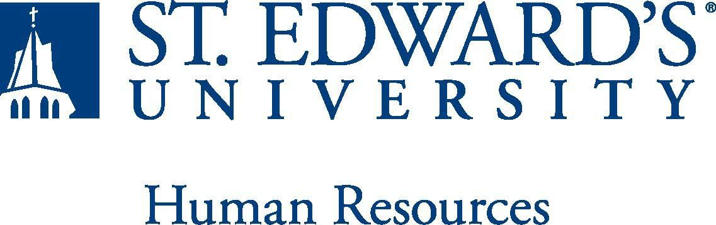

Job Title: Assistant Baseball Coach | FLSA Classification:  Exempt
Reports to: Head Baseball Coach | Location: RAC
Department: Athletics | Division:
Employment Category: Full Time | Paygrade: 415
PRIMARY PURPOSE OF POSITION

The assistant baseball coach will assist the university in meeting the specified goals of the mission statement and the athletic department through professional management of the baseball program (varsity and JV). The goals are to 1) provide opportunities and support for SEU student-athletes to achieve academically and athletically at the highest level and provide programming and resources that help build life skills, 2) provide every opportunity for the baseball program to compete for Lone Star Conference Championships every year, 3) operate with quality and integrity in the athletic department's role as a focal point for school identity and spirit, 4) support the community through public service.

ESSENTIAL DUTIES AND RESPONSIBILITIES

Assist head coach with coaching and administrative duties for the baseball program.
Primary
- Actively assist in the planning and direction of the overall practice strategy for both varsity and JV teams: Run aspects of practice to include:
  - instruct student-athletes in positional specific techniques (preferably catching)
  - instruct student-athletes in offensive development
  - instruct student-athletes in tactical strategies
  - instruct student-athletes in proper strength and conditioning techniques
- Make strategic decisions in contest situations.
- Travel nationwide for competition and recruiting.
- Counsel student-athletes concerning academic progress.
Secondary
- Assist in the overall recruiting strategy and implementation of evaluating, identifying and recruiting quality student-athletes; correspondence with prospective student athletes.
- Assist with equipment purchase and organization.
- Assist with camp operations and fundraising.
- Assist in oversight of team travel keeping budget considerations in mind.
- Chronicle and report NCAA required data to the athletic compliance office.
- Perform other administrative duties as assigned by the Director of Athletics.

QUALIFICATIONS
- Baccalaureate degree, preferably in Physical Education, Kinesiology, Sports Management, or Exercise Science; Master’s Degree preferred.
- Successful background in coaching and/or playing baseball; preferably at the NCAA level.
- Ability to successfully pass the NCAA recruiting examination within two months of hire.
- Excellent interpersonal, oral and written communication, administrative, and organizational skills.
- Basic familiarity, appreciation and empathy with the role of intercollegiate athletics and its relationship to the university, and the capacity to articulate that role and interact comfortably with those individuals and constituency groups (student-athletes, alumni, coaches, parents, etc.) crucial to the advancement of athletics at SEU.
- Highly motivated with a capacity for independent work within the context of an intensely goal-oriented environment.
- Successful completion of an employment and/or criminal background check is required.
WORKING CONDITIONS
The individual holding this position must be able to work nights, weekends and holidays to meet the needs of the department. Practice and games take place outdoors and weather conditions will vary.
PHYSICAL REQUIREMENTS
The expectations listed below are representative of the abilities that may be needed to fulfill the essential functions of this position. Reasonable accommodations may be made to enable individuals with disabilities to perform the essential functions. Physical strength/endurance to enable him/her to perform/participate in the following activities:

- Physically able to throw batting practice to the team.
- Physically able to hit fungo to the team.
- Physically able to lift various materials up to 75 pounds on an occasional basis.
- While performing required job tasks, physically able to bend, crouch and reach continuously.
- While performing required job tasks, physically able to remain seated, frequently to continuously.
- While performing required job tasks, physically able to remain standing up to or more than 50% of the time.
- Possesses dexterity abilities required to operate a computer and other office equipment to perform related job responsibilities.
SUPERVISORY RESPONSIBILITIES
As a full-time assistant coach, you will sometimes be required to supervise the graduate assistant position in execution of tasks.
EXPECTATIONS

- Strong organizational and time-management skills.
- Highly effective verbal and written communications skills.
- Excellent interpersonal skills, including collaboration, relationship building, and ability to respond positively and flexibly when working with all levels in the organization and with outside parties.
- Agility to work with student-athletes and coaches and should be comfortable speaking to groups of various sizes.
- Knowledge of NCAA DII and Lone Star Conference rules and regulations.
- Understanding of St. Edward’s University’s mission and goals is essential.
- Ability to work weekends and evenings is required. This position requires non-traditional hours.
- Ability to exercise and apply sound judgment and decision-making skills as well as the ability to maintain integrity and confidentiality of data.
- Advanced knowledge of Microsoft Office and Google Suite software programs.
- Ability to quickly learn new technology and be self-motivated to stay current with emerging technologies.
- Ability to edit work for spelling and grammar, present numerical data effectively and read and interpret written information. Demonstrates accuracy and thoroughness and monitors own work to ensure quality.
- Ability to adapt to change in the work environment, manage competing demands and deal with frequent change, delays or unexpected events.
- Ability to accept supervision, assignments, change and correction. Proven effectiveness in dealing with a wide range of professionals, staff, and administrators.
- Ability to balance priorities to accomplish assigned tasks within the required time frame and be able to shift quickly between several tasks without loss of continuity.
- Ability and desire to be a strong team player and develop team dynamics within the athletic staff
- Desire to engage in meaningful and intentional professional development appropriate for areas of responsibility and actively engage in personal and campus well-being initiatives.
- Ability to carry out all responsibilities and objectives in a professional manner.
- Ability to develop knowledge of, respect for, and skills to engage with those of other cultures or backgrounds in accordance with the Holy Cross Mission.
- Ability to adhere to the policies and procedures established by St. Edwards University.

This document describes the general purpose, duties and essential functions associated with this job and is not an exhaustive list of all duties that may be assigned or skills that may be required. I have read and understand my job description and acknowledge that management reserves the right to change or reassign job duties or combine jobs at any time.

Employee (Print Name): Date:

Employee (Signature): Date:

 | HR OFFICE USE ONLY:
Approved by: |  | Signature of the person with the authority to approve the job  description
Printed Name of  Approver: |  | Printed name of the person with the authority to approve the job  description.
Date  approved: |  | Date upon which the job description was approved
Reviewed: |  | Date when the job description was last reviewed

