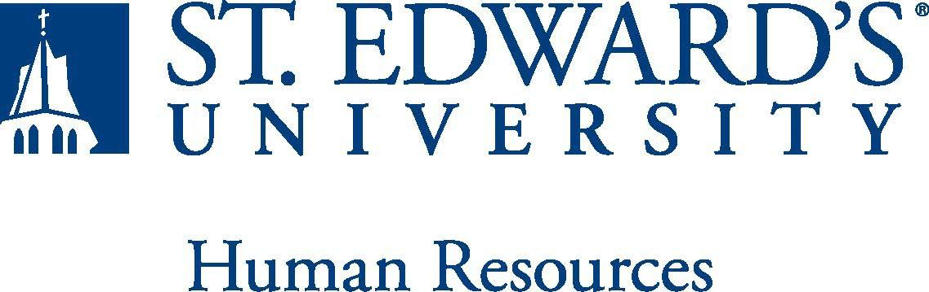

Job Title: Disability Counselor | FLSA Classification:  X Exempt ☐Nonexempt
Reports to: Director – Student Disability Services | Location:
Department: SDS | Division: Student Success Center (ACAD)
Employment Category:  X Full-Time ☐ Part-Time | Paygrade: 417
PRIMARY PURPOSE OF POSITION

It is the role of the Disability Counselor to ensure that all St. Edward’s students, Graduate, and Undergraduate, who are diagnosed with a disability, receive the services and accommodations that are within their legal rights. The position includes direct disability services, ongoing counseling/support and leadership across campus regarding compliance, advocacy and education regarding students with disabilities. The Disability Counselor upholds St. Edward’s mission by safeguarding the precept that there will be no discrimination either in the recruitment, admission, educational process, or treatment of students with disabilities. This position is supervised by the Director of Student Disability Services.

ESSENTIAL DUTIES AND RESPONSIBILITIES

Disability Counselor Responsibilities

- Determines if students qualify for disability services under the ADA, Section 504 and/or the Fair Housing Act, and approves academic accommodations based on individual needs.
- Reviews documentation related to disabilities and functional limitations
- Engages in the interactive process with students to clarify requests
- Provides referrals for documentation to off-campus services and resources as needed
- Maintains collaborative and consultative relationships, and mediation when appropriate, with faculty, staff, community resources, parents, and others involved in providing accommodations to qualified students.

Student Academic Support Responsibilities

- Maintains caseload of qualifying students with disabilities.
- Coordinates and monitors the effectiveness of direct disability services in collaboration with faculty and staff to ensure equal access to programs and services.
- Provides on-going academic counseling support, skill-building and advocacy services.
- Maintains student records in a confidential manner.
- Educates students regarding their disabilities: characteristics, learning and coping strategies.
QUALIFICATIONS
- Master’s degree in counseling, social work, higher education or related field
- Licensure or licensure eligible preferred, (i.e. LPC, LCSW, LMFT), experience working with people facing mental health challenges required
- Minimum of one to three years professional experience in an educational setting in an academic or mental health counseling role, higher education preferred.
- Working knowledge of the Americans with Disabilities Act Amendments Act (ADAAA), Section 504 of the Rehabilitation Act, the Fair Housing Act and all other relevant federal and state laws pertaining to individuals with disabilities.
- Ability to work with a diverse constituency including faculty, staff, and students.
- Excellent interpersonal, oral and written communication skills.
- Ability to follow workplace and attendance guidelines.
- Successful completion of an employment and/or criminal history background check required.
WORKING CONDITIONS
This is a 12-month exempt position and your expected work schedule is in person Monday through Friday 8-5. As an exempt employee your schedule may vary based on the number of hours needed to meet the job responsibilities. The individual holding this position may need to be available early morning, evening, and weekends to meet the needs of the department.
PHYSICAL REQUIREMENTS
The expectations listed below are representative of the abilities that may be needed to fulfill the essential functions of this position. Reasonable accommodations may be made to enable individuals with disabilities to perform the essential functions. Physical strength/endurance to enable him/her to perform/participate in the following activities:

- Physically able to lift various materials up to 25 pounds on an occasional basis.
- While performing required job tasks, physically able to bend, crouch and reach continuously.
- While performing required job tasks, physically able to remain seated, frequently to continuously.
- While performing required job tasks, physically able to remain standing up to 15% of the time.
- Possesses dexterity abilities required to operate a computer and other office equipment to perform related job responsibilities.
SUPERVISORY RESPONSIBILITIES
SUPERVISION RECEIVED: General supervision is provided by the Director.
EXPECTATIONS

Honor the values in the operating principles for St. Edward’s University:
- Work through collaboration: address concerns from a university-wide perspective, share information and meet deadlines; give and receive constructive feedback, listen with an open mind.
- Treat each other respectfully: speak to each other in professional and respectful tone; maintain composure and judgment under the pressure caused by differences, actively listen for understanding, clarify confusion, affirm feelings, and seek mutually beneficial solutions.
- Continually develop organization & take responsibility for excellence: commit to continuous assessment of the needs of students and take responsibility for continual analysis of policies, procedures, processes, as well as the individual’s own performance, to ensure effective and efficient work is always possible.
- Dedicated to high a standard of service: creative problem-solving skills, respond quickly, considerately, and correctly to the needs of those who need help. Continually work to increase job knowledge and knowledge about other areas of the university, and improve service. Willing to place higher priority on service than on administrative ease; politeness, cheerfulness, and helpfulness are valued and expected.
- Open communication: offer and accept suggestions for improvement, and be receptive to others' ideas and to changes related to continual assessment. Work to create the trust that makes open and direct communication possible.
- Understand and promote diversity: support the ideal of equal and open access to opportunity for everyone. Work to critically examine beliefs, biases, and assumptions that may create division and misunderstanding about ethnicity, gender, age, sexual orientation, values, religion, politics, disabilities, socio-economic status, attitudes, language, and all other differences.

This document describes the general purpose, duties and essential functions associated with this job and is not an exhaustive list of all duties that may be assigned or skills that may be required.

