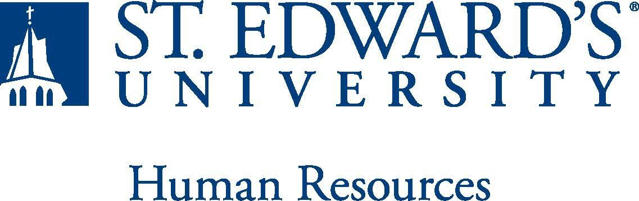

Job Title: Associate Director, Academic Counseling and Exploration | FLSA Classification:  - Exempt  - Nonexempt
Reports to: Director of Academic Counseling and Support Programs | Location:
Department: ACE | Division:
Employment Category:  - Full-Time ☐ Part-Time | Paygrade:
PRIMARY PURPOSE OF POSITION

Work with the Director of Academic Counseling and Support Programs to provide leadership and supervision to a team of Success Coaches in advising and counseling students in the Academic Counseling and Exploration Office (ACE). The Associate Director coordinates the academic orientation and first year transition of new students and supports the university's goals through developing and implementing a student-development approach to academic advising. The Associate Director supports student development in the Holy Cross tradition and provides customized, holistic, and proactive academic advising and case-management services to positively influence the student’s experience, as well as student retention, persistence, graduation rates, and post-graduation opportunities.

ESSENTIAL DUTIES AND RESPONSIBILITIES
- Assist Director in creating, implementing, leading, and analyzing academic advising and retention programs for students.
- Directly supervise a team of Success Coaches. Act as a point of reference or subject matter expert for any questions as well as be able to direct their work and evaluate their current student caseload.
- Coordinate, plan and implement special projects such as, but not limited to, an early alert/intervention program, advisor program, success programming, career development initiatives.
- Assist Director in monitoring and evaluating ACE services/special services operations, policies and procedures for effectiveness and efficiency and determine necessary revisions.
- Work with the Director to organize and coordinate information, materials and schedule for advising and registration during freshmen, transfer and international orientation.
- Assist Director in coordination of information from admissions and registrar’s office.
- As a member of ACE Leadership Team, provide seamless services and ensure referral and/or collaborative instructional support to students seeking help with academic needs.
- Act as a liaison between ACE and the Schools (Dean’s office, Department Chairs and Faculty)
- Work independently and collaboratively with members of the campus community in planning and implementing retention programs for students (i.e., new student orientation).
- Provide a high level of individual and general student care to include:
  - Advise students in academic program planning based on the student's academic and career goals, curricular requirements and policies, and on opportunities that can enhance students' collegiate success and career goals.
  - Perform college retention outreach and programming and participate in student success initiatives.
  - Collaborate with other departments within Student Support Services, including Academic Support Programs, Disability Services, Career and Professional Development, and Academic Departments to provide integrated advising to all first-year students.
  - Counsel students in plan of study, choice of major and other aspects of educational development and planning.
  - Facilitate access to other support services
  - Advise students, exercising discretion and independent judgment, on their selection of an academic major and/or career field.
- Work independently and collaboratively with members of the campus community in planning and implementing retention programs for students.
- Other duties as needed

QUALIFICATIONS
Bachelor’s and Master’s degree required in a closely related discipline from an appropriately accredited institution. The Associate Director must have a minimum of five years experience in academic advising/counseling in an institution of higher education. Demonstrated supervisory experience. Ability and experience in working with students from diverse backgrounds in student mentoring, tutoring, supplemental instruction, freshman transition issues, and students with academic challenges. Candidates for the position must demonstrate their ability to contribute to an evolving student experience team and be able to embrace change. Demonstrated ability to work collaboratively with individuals at various levels of an academic environment including but not limited to: students, faculty, staff and alumni. Must possess an unencumbered driver’s license and the ability to successfully pass a criminal background check.
This is an exempt position and your expected work schedule is Monday through Friday. As an exempt employee your schedule may vary based on the number of hours needed to meet the job responsibilities. The individual holding this position may need to be available early morning, evening, and weekends to meet the needs of the department.
WORKING CONDITIONS
PHYSICAL REQUIREMENTS
The expectations listed below are representative of the abilities that may be needed to fulfill duties of this position Reasonable accommodations may be made to enable individuals with disabilities to perform the essential functions. Physical strength/endurance to enable the individual to perform/participate in the following activities:
- Physically able to lift various materials up to 25 pounds on an occasional basis.
- While performing required job tasks, physically able to bend, crouch and reach continuously.
- While performing required job tasks, physically able to climb stairs, ladders or scaffolding as necessary.
- While performing required job tasks, physically able to remain seated, frequently to continuously.
- Possesses dexterity abilities required to perform typing, operate a computer and other office equipment, to perform filing, and related job responsibilities and attention to detail competence.
- Physically able to spend significant time reading both on paper and on a computer.
- Ability to travel by car and plane for University business. Ability to drive.

SUPERVISORY RESPONSIBILITIES
SUPERVISION RECEIVED: General supervision is provided by the Director of Academic Counseling and Support Programs.

SUPERVISION EXERCISED: Functional supervision is provided to Success Coaches.
EXPECTATIONS

The incumbent is expected to have or possess:
- Ability to work collaboratively as a team with both the student and the faculty advisor/ mentor in their major.
- Ability to inspire, motivate, and challenge students of all cultures.
- Possess a thorough understanding of university policies, procedures, requirements, and effectively communicate them to students.
- Maintain connections with faculty and staff across campus, especially, but not limited to the Office of First Year Experience, Academic Success Center, Undergraduate Admissions, Office of Student Financial Aid, Office of Scholarships, Residential Life, Special Services, and other offices as needed.
- Flexible in Work: ability to be nimble when working with students, faculty, colleagues and administration.
- Ability to work hard with positive energy, seizing opportunities to accomplish and exceed goals.
- Ability to be customer focused: dedicated to student development and success, establishes and maintains effective relationships with students and faculty to earn their trust and respect, possesses exceptional counseling, coaching, and mentoring skills.
- Ability to possess integrity & trust: widely trusted, truthful, admits mistakes, keeps confidences and can present the truth in an appropriate and helpful manner.
- Ability to possess listening skills: can accurately restate the opinions of others, practices attentive and active listening, while exhibiting patience for others.
- Ability to handle highly confidential material, understanding that all University information should only be disclosed to others who have a need to know, for legitimate business reasons. Have the ability to exercise and apply sound judgment and decision making skills as well as the ability to maintain integrity and confidentiality of data.
- Has advanced knowledge of Microsoft Office and Google Suite software programs. Ability to quickly learn new technology and is self-motivated to stay current with emerging technologies.
- Ability to edit work for spelling and grammar, present numerical data effectively and is able to read and interpret written information. Demonstrates accuracy and thoroughness and monitors own work to ensure quality.
- Ability to possess excellent communication, organizational, problem- solving skills.
- Adapt to change in the work environment, manage competing demands and able to deal with frequent change, delays or unexpected events.
- Ability to accept supervision, assignments, change and correction. Proven effectiveness in dealing with a wide range of professionals, staff, and administrators.
- Ability to balance priorities to accomplish assigned tasks within the required time frame and be able to shift quickly between several tasks without loss of continuity.
- Engage in meaningful and intentional professional development appropriate for areas of responsibility and actively engage in personal and campus well-being initiatives.
- Carry out all responsibilities and objectives in a professional manner.
- Accept and render constructive criticism in a professional manner.
- Flexible in Work: ability to be nimble when working with students, faculty, colleagues and administration
- Ability to develop knowledge of, respect for, and skills to engage with those of other cultures or backgrounds in accordance with the Holy Cross Mission.
- Adhere to the policies and procedures established by St. Edward's University.

This document describes the general purpose, duties and essential functions associated with this job and is not an exhaustive list of all duties that may be assigned or skills that may be required.
I have read and understand my job description and acknowledge that management reserves the right to change or reassign job duties or combine jobs at any time.

Employee (Print Name): Date:

Employee (Signature): Date:

 | HR OFFICE USE ONLY:
Approved by: |  | Signature of the person with the authority to approve the job  description
Printed Name of  Approver: |  | Printed name of the person with the authority to approve the job  description.
Date  approved: |  | Date upon which the job description was approved
Reviewed: |  | Date when the job description was last reviewed

