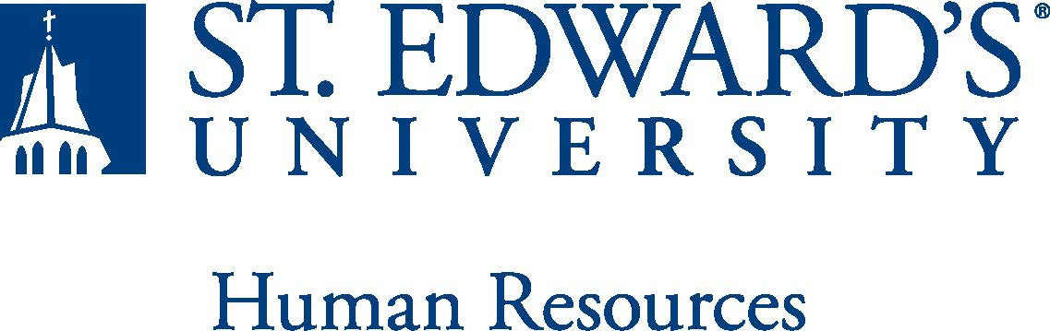

Job Title: Director for Career and Professional Development | FLSA Classification:  X Exempt ☐Nonexempt
Reports to: AVP Student Success | Location:  MH
Department: CAPD | Division: Student Success Center
Employment Category:  X Full-Time ☐ Part-Time | Paygrade:
PRIMARY PURPOSE OF POSITION

The Director for the Office of Career and Professional Development will be responsible for providing the strategic direction, vision and leadership for the office in support of the University Strategic Plan for 2027. This position includes supervision of professional staff, identification and development of internship/employment opportunities and educational trends to meet the changing needs of students and employers, the development and promotion of career programs and services, and budget management. The Director leads and manages the delivery of career development and exploration services for all undergraduate and graduate students and alumni of the university. Working together with the Career and Professional Development team, academic school leadership and University campus partners, the Director will create plans to build and enhance resources, programs, external partnerships and support for students, with special attention for those who are from marginalized and underrepresented backgrounds.
ESSENTIAL DUTIES AND RESPONSIBILITIES

- Provide leadership in the development and implementation of the Office for Career and Professional Development mission, vision, goals, objectives and annual strategic plan.
- Collaborate with the Student Engagement and Communications Coordinator and Career and Professional Development staff to manage employer relations, job development, and recruitment activities.
- Provide leadership, supervision, and budget administration for Career and Professional Development.
- Provide leadership in the development of programs and initiatives that assist in obtaining employment and internships.
- Present career development skill-building workshops on subjects such as resume writing, interviewing, graduate school applications, and utilizing social media in job and internship searches, etc.
- Oversee Career and Professional Development related programmatic/initiative development for all student and alumni populations: undergraduate and graduate.
- Oversee and manage key programs, such as Community Federal Work Study and Donor-funded internships and experiential learning opportunities.
- Establish campus-wide collaborative relationships with Deans, Directors, Department Heads, and other internal stakeholders.
- Meet with academic leaders and faculty on a regular basis to determine needs, provide support, and develop programs, services, and opportunities.
- Monitor local and statewide workforce needs and identify opportunities for students and graduates to address these needs and gaps.
- Maintain and continue to grow mutually-beneficial relationships with business, governmental, and non-profit communities to enhance employment and dedicated internship opportunities.
- Lead efforts to engage and train community organizations in hiring, supervising and mentoring students and graduates.
- Manage coordination of internships and other career exploration experiential learning programs.
- Leverage social media to promote the mission of the Career and Professional Development Office and communicate job opportunities.
- Provide and encourage ongoing professional development for Staff. Develop and conduct annual assessment and evaluation of the department.
- Work with alumni to participate in programs and recruit at the university.
- Collaborate with the Student Engagement and Communications Coordinator to manage office marketing and web presence.
- Serve as the liaison to academic schools and campus partners for career education planning.
- Meet with academic advising staff, internship coordinators, employers, administrators, faculty, and student organization leaders to maintain communication and provide support.
- Administer events designed to meet the needs of these students.
- Provide employment and student data to department chairs and administration on an annual basis.
- Administer the University Beyond the Hilltop Survey on semesterly basis in collaboration with Institutional Effectiveness and Planning.
- Manage University Handshake platform. Manage departmental vendor contracts. Supervise Associate Director/Employer and Internship Relations and career coaches.
- Perform other related duties as assigned.
QUALIFICATIONS

Bachelor's degree required. Graduate degree preferred. Minimum of 5 years in career planning and job and internship placement; seven year preferred. Management and supervisory experience required. Career planning experience or translatable skills required. Strong interpersonal, communication, presentation and public speaking skills required. Ability to work comfortably with high-level administrators, both internally and externally. Familiarity with web-based resources and design, and Internet manipulation. Experience using social media tools for outreach and marketing. Understanding of how to lead a team and succeed in a cross-functional work environment. Understanding of corporate hiring processes, college career centers and career development trends. Strong written and verbal communication skills in order to work with high profile employers, students, faculty, and university administrators. Experience with Microsoft Office: Outlook, Word, Excel, Power Point and Google Suite. Ability to analyze and use data as decision-making tools. Experience or knowledge of best practice when working with international students and special populations. Successful completion of an employment and/or criminal history background check required.

Preferred Qualifications
Master's degree in a related area. Knowledge of employment and career services management software (the St. Edward's University Career and Professional Develop Office uses Handshake). Grant administration experience preferred.

Typical office environment
WORKING CONDITIONS
PHYSICAL REQUIREMENTS

- Physically able to lift various materials up to 25 pounds on an occasional basis.
- While performing required job tasks, physically able to bend, crouch and reach continuously.
- While performing required job tasks, physically able to remain seated, frequently to continuously.
- While performing required job tasks, physically able to remain standing up to 15% of the time.
- Possesses dexterity abilities required to operate a computer and other office equipment to perform related job responsibilities.

SUPERVISORY RESPONSIBILITIES
Associate Director, CAPD
4 Career Coaches
EXPECTATIONS

This document describes the general purpose, duties and essential functions associated with this job and is not an exhaustive list of all duties that may be assigned or skills that may be required.

