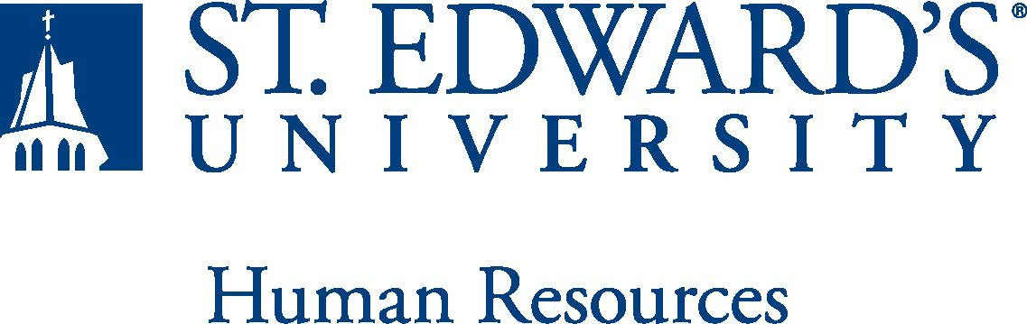

|  |  |
| --- | --- |
| **Job Title:**  Assistant Strength and Conditioning Coach | **FLSA Classification:**  X Exempt ☐Nonexempt |
| **Reports to:**  Head Strength and Conditioning Coach | **Location:**  Recreation and Athletic Center |
| **Department:** Athletics | **Division:** Student Affairs |
| **Employment Category:**  X Full-Time ☐ Part-Time | **Paygrade:** 413 |

**PRIMARY PURPOSE OF POSITION**

The Assistant Strength and Conditioning Coach will assist with the design, implementation, development, and management of individual and group strength and conditioning programs for both men and women student-athletes participating in intercollegiate athletic programs.

**ESSENTIAL DUTIES AND RESPONSIBILITIES**

* Assist in the development and implementation of individualized strength and conditioning programs in collaboration with head coaches and athletic trainers to effectively train teams and accommodate injured student-athletes.
* Assist in the development of twelve-month sport-specific resistance programs.
* Assist in the development of conditioning programs that address the cardiovascular demands of the sport.
* Assist in the development of flexibility/stretching programs.
* Assist in evaluating current physical conditioning
* Responsible for continuous testing and evaluations of student athletes’ physical fitness including but not limited to strength, power, endurance, cardiovascular fitness, and flexibility
* Assist in documentation of athletes' workouts and monitor progression.
* Provide direct instruction to all student-athletes, demonstrating proper performance of exercises, and correcting mistakes in order to assure proper explanation of training techniques.
* Assist in tailoring strength programs for specific needs, demonstrating proper performance of exercises, correcting mistakes
* Can communicate effectively with sports coaches regarding their programs, athlete updates, and injury modifications
* Assist in the development of strength and conditioning manuals used by off-term and/or summer student-athletes.
* Provide educational support regarding nutritional and supplemental products, sleep, and healthy living practices and reinforce a drug-free environment, in accordance with FDA recommendations and NCAA guidelines.
* Assist in the management and control of the day-to-day operations of the varsity weight room.
* Maintain and enforce policies and procedures for the use and risk management of the weight room.
* Ensure the weight room and all equipment is cleaned and organized daily and in compliance with health and safety mandates.
* Ensure proper maintenance of equipment, including regular inspection, and recommendation on repair/replacement/new equipment for purchase to ensure that student-athletes have the equipment and resources to maximize their strength and conditioning efforts.
* Work compatibly and cooperatively with athletics administrative and support staff, sports coaches, and student-athletes.
* Assist with training, supervising, and evaluating student workers / interns.
* Maintain knowledge of, and compliance with, specific NCAA, Lone Star Conference rules, HCAC, and institutional rules and regulations that relate to this position as required.
* Maintain NCAA-mandated certification(s) through completion of continuing education and up-to-date CPR/AED training.
* Be an active member of the Department of Athletics staff by attending staff meetings and other department-scheduled activities.
* Contributes to a work environment that encourages knowledge of, respect for, and development of skills to engage with those of other cultures or backgrounds.
* Be responsive and timely with all requests from departmental support staff.
* Assist in game management duties for sports programs.
* Communicates and collaborates with a variety of individuals, including the sports medicine staff, coaches, administrators, and various offices on campus providing wellness events and services. Assists in the development and implementation of new wellness initiatives.
* Promotes a positive image of the intercollegiate athletics program and the University by participating in community and professional organizations, representing the University at professional meetings and on community committees
* Perform other duties as assigned by the Head Strength and Conditioning coach and the Assistant Athletics Director for Sports Medicine.
* All department employees are required to demonstrate exemplary ethical conduct and conformance to NCAA rules and regulations~~;~~ .
* the duties of the position are to be performed in compliance with all NCAA, Conference, and College rules and regulations; and any rules violations on behalf of themselves or any knowledge of violations within the department are to be reported to the appropriate parties.
* Violation of NCAA and other University or Conference regulations shall be subject to possible disciplinary action.
* Responsible for regulatory and policy compliance as it applies to the position.
* Perform other duties as assigned.

**QUALIFICATIONS**

* A Bachelor’s Degree in Kinesiology/Exercise Science or related field from an accredited institution is required; a master’s degree is preferred.
* At least one year of collegiate strength and conditioning coaching experience.
* Certifications and Licenses:
* Current certification through a nationally accredited strength and conditioning certification program (National Strength and Conditioning Association and Collegiate Strength
* Conditioning Coaches Association are both accredited) in accordance with NCAA guidelines. First Aid and CPR certified.
* Must maintain a valid U.S. Driver’s License. Certifications and licensures must be kept in good standing at all times.
* Must possess excellent organizational skills, effective communication and interpersonal skills, and an ability to work productively with coaches, staff, and student-athletes.
* Must be flexible and possess the ability to successfully handle multiple tasks/projects simultaneously and work well under pressure, independently, and in a team-oriented environment.
* Basic knowledge of and commitment to NCAA DII rules.
* Successful completion of an employment and/or criminal history background check is required.

**WORKING CONDITIONS**

The ability to work early mornings, evenings, and weekends to meet the needs of the department.

This position works for 10 months out of the year.

**PHYSICAL REQUIREMENTS**

* Physically able to lift various materials up to 25 pounds on an occasional basis.
* While performing required job tasks, physically able to bend, crouch and reach continuously.
* While performing required job tasks, physically able to remain seated, frequently to continuously.
* While performing required job tasks, physically able to remain standing up to 25% of the time.
* Possesses dexterity abilities required to operate a computer and other office equipment to perform related job responsibilities.

**SUPERVISORY RESPONSIBILITIES**

Supervise student workers and interns.

**EXPECTATIONS**

* Maintain confidentiality.
* Work effectively with a diverse faculty, staff, student body, alumni, and community.
* Model inclusive excellence through actions that support the university’s diversity commitment.
* Adhere to the policies and procedures established by St. Edward’s University.

*This document describes the general purpose, duties and essential functions associated with this job and is not an exhaustive list of all duties that may be assigned or skills that may be required.*

*I have read and understand my job description and acknowledge that management reserves the right to change or reassign job duties or combine jobs at any time. This document does not represent a contract of employment.*

Employee (Print Name): Date:

Employee (Signature): Date:

|  |  |  |
| --- | --- | --- |
|  | HR OFFICE USE ONLY: | |
| **Approved by:** | | *Signature of the person with the authority to approve the job*  *description* |
| **Printed Name of**  **Approver:** | | *Printed name of the person with the authority to approve the job*  *description.* |
| **Date**  **approved:** | | *Date upon which the job description was approved* |
| **Reviewed:** | | *Date when the job description was last reviewed* |